Příloha
ke Sdělení proděkana pro pedagogickou činnost č. 2/2016
Pravidla pro psaní disertačních prací na FROV JU

Vzor textu disertační práce

Study on the compatibility of germ cells after transplantation into a recipient

Studie kompatibility zárodečných buněk po transplantaci příjemci

Rigolin Nayak

I, Rigolin Nayak, thereby declare that I wrote the Ph.D. thesis by myself using results of my own work or the collaborative work of me and colleagues and with help of other publication resources which are properly cited.

I hereby declare that in accordance with the § 47b Act No. 111/1998 Coll., as amended, I agree with publicizing of my Ph.D. thesis in full version electronically in a publicly accessible part of the STAG database operated by the University of South Bohemia in České Budějovice on its web sites, with keeping my copyright to the submitted text of this Ph.D. thesis. I also agree so that the same electronic way, in accordance with above mentioned provision of the Act No. 111/1998 Coll., was used for publicizing reviews of supervisor and reviewers of the thesis as well as record about the progress and result of the thesis defence. I also agree with compering the text of my Ph.D. thesis with a database of theses “Theses.cz” operated by National Register of university theses and system for detecting of plagiarisms.

In Vodňany 30th April, 2024

………………………………
Supervisor:
Assoc. Prof. Ing. Martin Pšenička, Ph.D.
University of South Bohemia in České Budějovice (USB)
Faculty of Fisheries and Protection of Waters (FFPW)
Research Institute of Fish Culture and Hydrobiology (RIFCH)
Zátiší 728/II, 389 25 Vodňany, Czech Republic

Consultant:
Mujahid Ali Shah, PhD
University of South Bohemia in České Budějovice (USB)
Faculty of Fisheries and Protection of Waters (FFPW)
Research Institute of Fish Culture and Hydrobiology (RIFCH)
Zátiší 728/II, 389 25 Vodňany, Czech Republic

Head of Laboratory of Germ Cells
Assoc. Prof. Ing. Martin Pšenička, Ph.D.

Reproductive and genetic practices for fish biodiversity conservation and aquaculture
(RP1)
Assoc.Prof. Dipl.-Ing. Martin Pšenička, Ph.D. (Head of the research program)

Dean of Faculty of Fisheries and Protection of Waters:
Prof. Ing. Tomáš Policar, Ph.D.

Board of doctorate study defence with referees:
Head of the board: prof. Ing. Lukáš Kalous, Ph.D.
Board members:
doc. Ing Pavel Horký, Ph.D.
doc. RNDr. Ing. Vladimír Krylov, Ph.D.
doc. Ing. Martin Kocour, Ph.D.
doc. Ing. Jan Mráz, Ph.D.
doc. M.Sc. Borys Dzyuba, Ph.D.

Dr. Taiju Saito, Associate Professor, Ehime University, Japan – thesis reviewer
Dr. Marta Lombó Alonso, Departamento de Biología Molecular, Universidad de León
León, Spain – thesis reviewer

Date, hour, and place of Ph.D. defence:
16th September, 2024, - 10:30 AM, FFPW, RIFCH, Vodňany, Czech Republic

Name: Rigolin Nayak

Title of thesis:
Study on the compatibility of germ cells after transplantation into a recipient
Studie kompatibility zárodečných buněk po transplantaci příjemci

Content

Chapter 1 5
General Introduction
Chapter 2 23
Enhancement of zebrafish sperm production via a large body-sized surrogate with germ cell transplantation
Chapter 3 34
Genome-wide comparative methylation analysis reveals the fate of germ stem cells after surrogate production in teleost
Chapter 4 52
Partial gonadectomy: A new approach to obtain germline stem cells for transplantation while preserving the donor
Chapter 5 65
General Discussion 66
English Summary 75
Czech Summary 76
Acknowledgements 77
List of Publications 78
Training and Supervision Plan during Study 79
Curriculum Vitae 81

Chapter 1

General Introduction

1. General Introduction

Surrogate production in fish offers an enormous opportunity to restore and propagate endangered or commercially valuable species through germ stem cell transplantation into a recipient. Other possible applications may include increasing gamete production or reducing the sexual maturation time. However, the success of surrogate production always depends on factors such as 1) the compatibility of transplanted germ cells with the recipient’s gonadal somatic cells, 2) achieving complete sterility of the recipient, 3) choosing the right developmental stage for the transplantation, and 4) selection of suitable germ cell type. The presented thesis thoroughly discusses the germ cell precursors, their development, and the techniques used for surrogate production in Chapter 1. The thesis deals with xenogenic germ stem cell transplantation from a smaller species with a low amount of gametes into a significantly highly fecund larger species (chapter 2). The epigenetic changes of transplanted germ cells in two kinds of recipients are discussed in Chapter 3. It covers our understanding of the reliability of the surrogate production approach in aquaculture and its future applications. The following chapter deals with the harvesting of viable germ stem cells from two smaller species via partial gonadectomy without sacrificing the donor individuals (Chapter 4). Overall, this thesis provides a thorough understanding of germ stem transplantation with potential experimental studies using three types of freshwater species: Giant danio (Devario aequipinnatus), zebrafish (Danio rerio), and pearl danio (Danio albolineatus). This thesis consists of two published (Chapters 2 and 3) and one unpublished study (Chapter 4).

  - Germ cells and their precursor
Germ cells are the only cells that give rise to a whole organism and are responsible for transmitting genetic information between generations. They have a unique potential to self-renew in order to maintain the stem cell population in the gonad and also differentiate to produce either gametes upon meiotic division. The primordial germ cell (PGC) is the origin or precursor of the germline cells, which is set aside from the somatic cells at a very early stage of embryonic division (Wylie, 1999) is the process known as PGC specification and later migrates to the presumptive gonadal anlagen. In this discussion, the author only focuses on the PGC specification and migration in teleost. PGC specification is determined by the maternally derived factors rich in RNA and protein molecules called germ plasm (Xu et al., 2010). PGC localization was described by Yoon et al., who cloned zebrafish vasa (now ddx4) homologue (vas) to analyze the RNA expression in the PGCs (Yoon et al., 1997). Other genes, such as nanos-1, dazl, and dead end, were also discovered to be associated with germplasm (Raz, 2003). In zebrafish, as per the ddx4 RNA location, the germplasm is first divided into two clumps and located along the cleavage planes at the 2-cell stage embryo, later condenses into four clumps at the 4-cell stage. PGCs are formed before the gastrulation, and their specification occurs at four distinct locations during the 1k-cell stage. PGCs undergo 2-3 mitotic cell division, reaching 25-30 in total cell number before migration (Lubzens et al., 2010). All the cells eventually migrate in the same direction and arrive where the gonad develops (Yoon et al., 1997). PGCs migrate towards the final target with the help of somatic cells that provide the directional cues on the route. The starting position of the PGCs varies among individual embryos and is known to be random with respect to their embryonic axis (Weidinger et al., 1999; Raz, 2003). The ligand stromal-cell-derived factor (SDF)-1a, a CXC subfamily chemokine secreted by the somatic cells, provides the directional cues for PGC migration. SDF-1a interacts with the seven-trans-membrane G protein-coupled receptor CXCR4b. The cxcr4b RNA is uniformly distributed in the embryo during the onset of PGC migration at early gastrulation. Later, at the late gastrulation, the expression is more specific to the PGCs that align along the lateral plate mesoderm of the trunk and the border between the head and the trunk mesoderm and continue expressing during migration until they arrive at the location where the gonad will be formed (Doitsidou et al., 2002). A strong correlation between the position of the PGCs at different stages of their migration and the tissues expressing high levels of sdf-1a transcripts was reported by Doitsidou et al., suggesting the essential role of SDF-1a in providing directional information to the migrating PGCs. SDF-1a acts as a natural chemoattractant for zebrafish PGCs. The migrating PGCs are very sensitive to the level of sdf-1a expression, allowing their precise migration to the final target (Doitsidou et al., 2002). In addition, a decoy receptor, CXCR7b, is structurally related to CXCR4b (Mahabaleshwar et al., 2008), plays an important role in PGC migration. It acts as an antagonistic and has been reported to play a crucial role in controlling precise temporal and spatial SDF-1a activity in somatic tissues and proper migration of PGCs. The binding of SDF-1a to the CXCR4b receptor activates downstream signaling cascades, leading to cell polarization and directed migration. In contrast, the binding of CXCR7b to SDF-1a in the somatic cells leads to ligand sequestration and lysosomal degradation of SDF-1a (Mahabaleshwar et al., 2008). PGCs migrate towards several intermediate targets before arriving at their final target and encounter different somatic structures that potentially provide directions (Olsen et al., 1997; Yoon et al., 1997). Upon their arrival at the gonadal anlagen, PGCs coalesce with gonadal somatic cells and colonize. Once sexual differentiation occurs, germ cells in male and female gonads take different paths. Eggs are produced in the female after the oogonia and oocyte stages. In contrast, germ cells in the male differentiate into mature sperm after the spermatogonia and spermatocyte stages, depending on the sex determination mechanism.

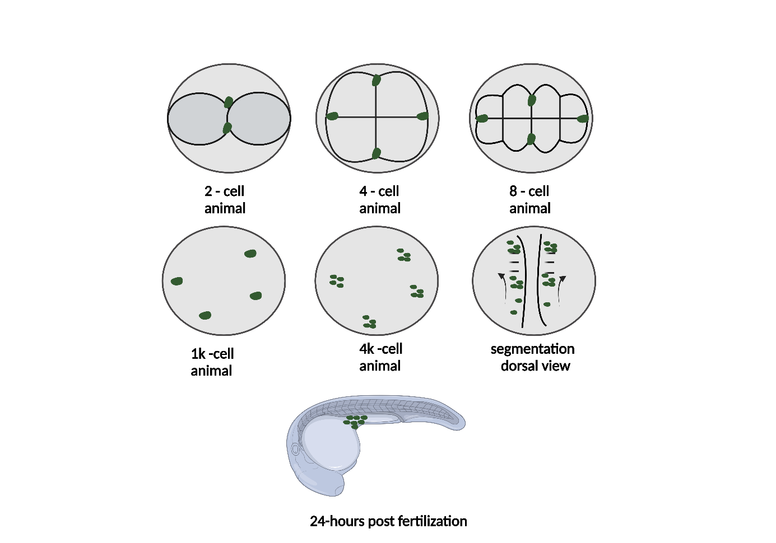
Figure 1. PGC specification and migration. Schematic representation of PGC specification and migration during zebrafish embryonic development. The drawing depicts the distribution of ddx4 RNA in two positions at the 2-cell stage and later in four positions at the 4- and 8-cell stages. These four clumps segregate into four cells (now PGCs) during the 1k-cell stage. At the 4k-cell stage, the PGCs undergo mitosis and divide. The clusters then migrate during the somitogenesis until they reach the gonadal somatic precursors, which is achieved over the course of 24 hours post-fertilization. Green circles represent the PGCs at different developmental stages. This image is modified from (Yoon et al., 1997; Raz, 2003). This figure is created using Biorender.com.

The sex determination (SD) system determines an organism's sexual fate and initiates gonad differentiation. The SD in teleost is complex and may be influenced by multiple factors such as temperature, pollutants, pH, and other environmental cues, irrespective of their genetic makeup (Devlin and Nagahama, 2002). In zebrafish, the SD is polygenic, where multiple alleles are at play rather than controlled by a single pair of sex chromosomes (Liew et al., 2012; Liew and Orbán, 2014). All juvenile zebrafish first possess an undifferentiated ovary-like gonadal structure in the beginning, regardless of their genotypic sex, which undergoes sex-reversal in male individuals after 20 days post-hatching and transforms into testis, a phenomenon known as hermaphroditism in fish (Yamamoto, 1969). All ovarian gonadal cells undergo programmed cell death in males, and the testicular differentiation resumes (Uchida et al., 2002).

The gonial cells –
This part of the discussion deals with the germ cell development and the path PGCs cover after colonizing the undifferentiated gonad, called gonocytes. The gonocytes differentiate into spermatogonia and oogonia depending on the phenotypical sex of the organism. PGCs and the gonial cells are biopotential before the onset of meiosis. Spermatogenesis is an orderly process where diploid spermatogonia proliferate and differentiate to generate millions of mature and flagellated haploid spermatozoa. Spermatogenesis is a continuous process where undifferentiated spermatogonia self-renew to maintain the balance between stem cells and differentiated spermatogonia in order to continue spermatozoa production throughout life. This process is completed in three different phases: 1) spermatogonial or mitotic phase, where type A undifferentiated spermatogonia (A_{und}) gives rise to Type A differentiated spermatogonia (A_{diff}) with reduced potential for self-renewal, Type A spermatogonia differentiates and generated Type B spermatogonia. Type B spermatogonia has several generations based on their morphological aspects, which vary between species (Schulz et al., 2010). 2) Type B spermatogonia undergoes first meiotic division to produce primary spermatocytes, followed by second meiotic division to produce secondary spermatocytes, and 3) the spermiogenic phase, where the spermatids undergo differentiation to produce a large number of haploid and motile spermatozoa (Schulz et al., 2010). Unlike spermatogenesis, oogenesis produces a limited number of mature eggs upon spawning. PGCs transform into oogonia, followed by meiotic division to produce primary oocytes. Primary oocytes undergo vitellogenesis to accumulate nutrition and maternal RNA essential for early embryo development. Finally, ovulation takes place after the maturation of the secondary oocyte (Lubzens et al., 2010).

  - Germ cell-based biotechnologies
Germ cell biology received enormous attention with the development of germ cell-specific markers that opened several windows to study germ cell development, visualization, and migration. New-age technologies have developed approaches to isolate, culture, and genetically manipulate germ cells in order to produce transgenic animals. Germ cell markers have contributed to producing gametes through germline chimeras with germ cell transplantation into xenogenic and allogenic recipients; the approach is also known as surrogate production. Surrogate production involves a systematic procedure: 1) harvesting donor germ stem cells (GSCs), 2) endogenous germ cell depletion of the recipient, also known as sterilization of the host, and 3) transplantation of donor GSCs into the recipient. Selecting a suitable GSC type and a transplantation method with higher efficiency is a prerequisite for surrogate production. This author aims to discuss all the methods associated with germ cell transplantation and their limitations and complexity, which may provide new insight for future studies. Genetic improvements through biotechnologies and elucidating the questions associated with these manipulating techniques are the sole purpose of this thesis.

    - PGC transplantation
PGC manipulation received prominence with the identification ddx4 homolog gene that encodes an ATP-dependent RNA helicase of the DEAD box family and is expressed exclusively in germ cell lineage, which enables the visualization of PGCs during their migration to the genital ridge using green fluorescent protein (GFP) reporter driven by the cis-regulatory elements of ddx4 gene that leads to GFP-specific gene expression in the germ cells (Yoshizaki et al., 2002; Kobayashi et al., 2004). Following the identification of the ddx4 gene, other germ cell-specific markers such as nanos1 (nos1) in zebrafish (Köprunner et al., 2001) and oryzias latipes ddx4 homolog (olvas) in medaka (Kurokawa et al., 2006), were used in teleost to localize PGCs and found to be conserved among species (Maegawa et al., 2002). First PGC transplantation in rainbow trout, where PGCs were isolated from the genital ridges of the hatched larvae and transplanted into the peritoneal cavity of the recipient larvae; subsequently, the transplanted PGCs incorporated into the recipient gonadal somatic cells and differentiated to generate donor-derived gametes (Takeuchi et al., 2003). Following these achievements, Saito et al. demonstrated a precise developmental stage for PGC transplantation between divergent teleost species, where isolated single PGC from the 10-15 somite embryo showed promising results for germline chimera production when transplanted into the marginal region of the blastulae stage embryo (Saito et al., 2008, 2010). They also reported that PGCs isolated from the later developmental stages lost their migration abilities. PGCs retrieved from the 24-hour cultured blastomere retained the potential to differentiate into functional gametes in germline chimera (Kawakami et al., 2010).

Combining PGC cryopreservation with transplantation could be a potential way to preserve the genetic resource of valuable transgenic lines produced to use as models for developmental and other genetic studies. Notably, zebrafish develop into a phenotypical all-male mono-sex population after germ cell depletion and require an absolute number of PGCs to stabilize the ovarian fate (Tzung et al., 2015). In that case, a high number of PGC transplants into the sterile embryo could produce fertile female germline chimera in zebrafish (Zhang et al., 2020). However, this strategy is labor-extensive and skill-sensitive. The present thesis addresses this question by using a genetically compatible larger species in Chapter 2 with gonial cell transplantation. PGC could be the ideal candidate for genome editing to induce desirable traits post-transplantation (Van De Lavoir et al., 2006; Xiong et al., 2013). However, one must focus on the complexity associated with PGC transplantation. Although the incorporation efficiency may be higher with PGCs as they are totipotent and committed to the germ cell lineage fate, the micromanipulation skills required to isolate the single PGCs and their precise transplantation into the recipient seem complicated and not very straightforward. It looks rather theoretical to generate a handful of germline chimera with single PGC transplantation, considering the limited number of PGCs that could be isolated from a single donor individual (Takeuchi et al., 2004). Recently, Wang et al. reported a novel approach to induce a higher number of presumptive PGCs from the zebrafish blastoderm cells using a mRNA cocktail of 9 germplasm factors related to PGC specification and migration, where PGCs from one donor embryo enabled transplantation into 30 recipients (Wang et al., 2023). However, whether this approach is efficiently applicable to other species remains to be seen. Survival of the transplanted embryos is another obstacle that needs special attention in PGC transplantation. Furthermore, isolating PGCs from the donor embryo requires transient or permanent labeling of germ cells. In some species, the generation of the transgenic line is challenging, and temporary germ cell labeling is often performed by microinjection of synthesized mRNA containing GFP reporter regulated by ddx4 or nanos1 promoter region into the one-cell stage embryo (Saito et al., 2008). However, transient labeling doesn’t guarantee the labelling of all the PGCs in the embryo, and the effect is not long-lasting. Moreover, microinjection is challenging for some marine species where breeding is implausible in captivity. Harvesting a higher number of PGCs is also a difficult task since PGC culture and induction are not optimized for all species. Considering these limitations, gonial cell transplantation may be feasible for many species in surrogate production, which is discussed in the next section.

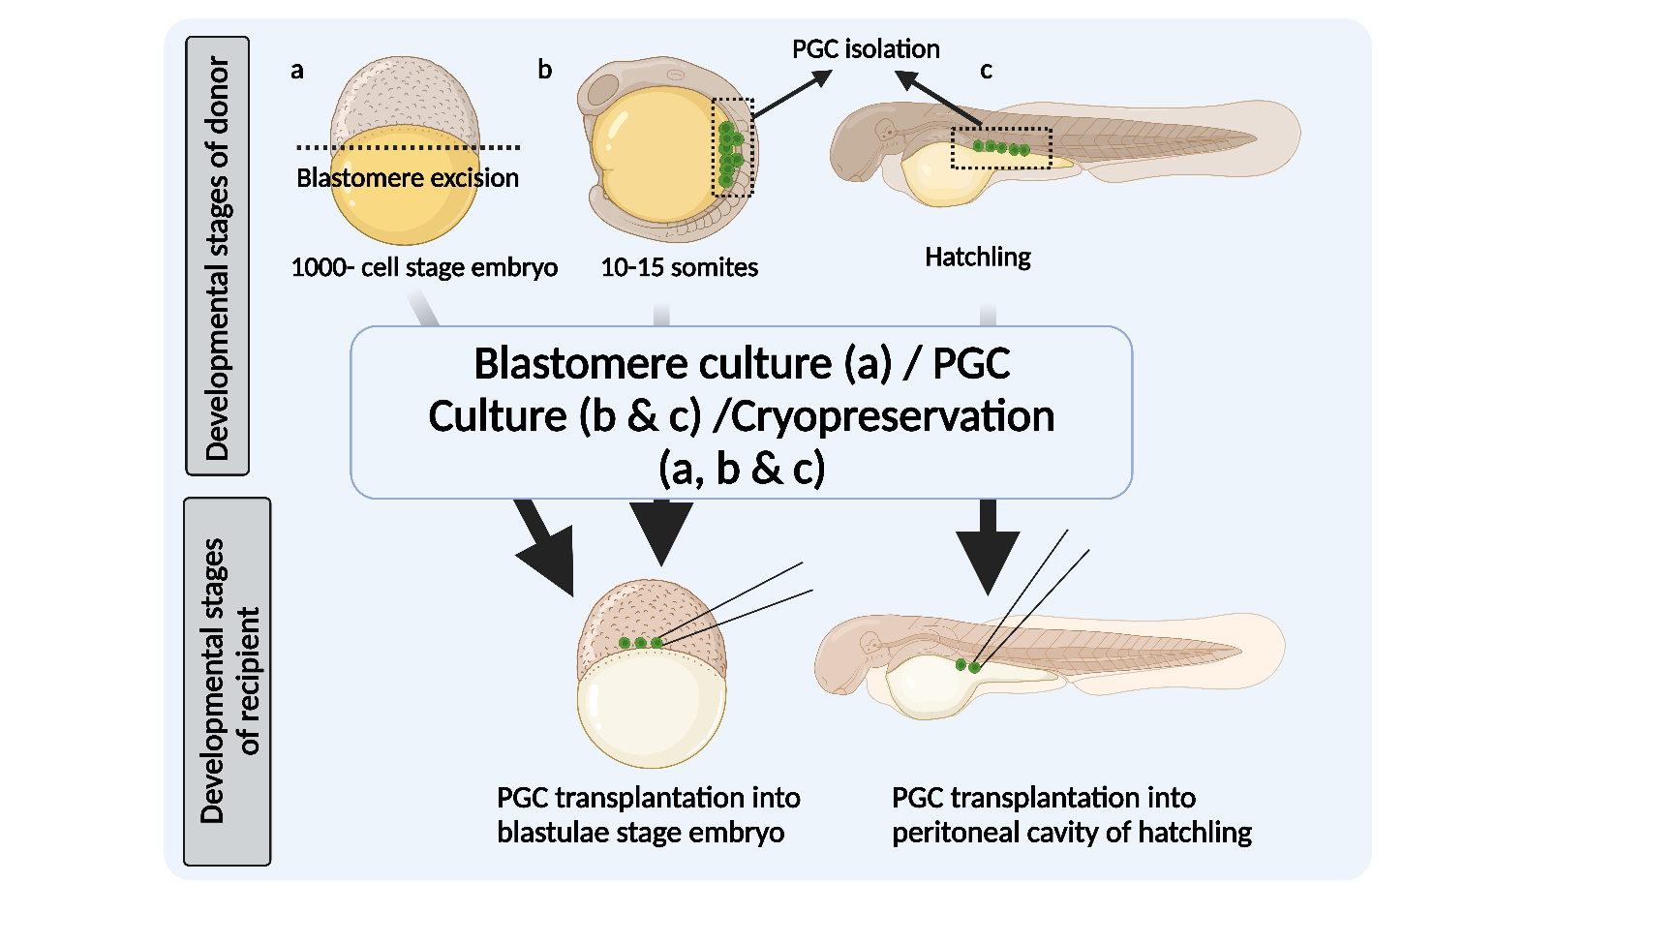

Figure 2. An overview of PGC transplantation. The schematic diagram for the PGC transplantation using the blastomere from a 1k-cell stage embryo that can be cultured to induce PGC production followed by long-term preservation using cryopreservation technique and transplanted upon requirement into the 1k-cell stage embryo (a). PGCs harvested from 10-15 somite stage embryos can be transplanted into the blastulae stage embryo and can also be cultured for cell expansion and cryopreserved for long-term storage (b). PGCs that have already migrated into the genital anlagen can be harvested and used for cryopreservation, culture, and transplantation into the same-stage embryo (c). This figure is created using Biorender.com.

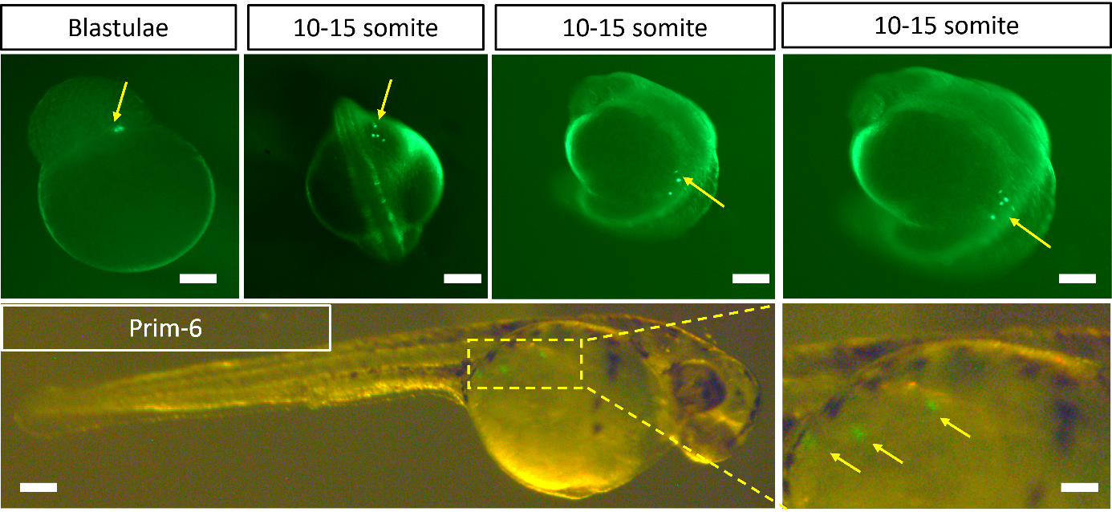

Figure 3. PGC transplantation in zebrafish. PGCs from the vasa::EGFP transgenic zebrafish were transplanted into the AB wildtype sterile embryos at the mid-blastula stage. The yellow arrow indicates the transplanted donor PGCs and their migration at developmental stages until the Prim-6 stage. This transplantation was performed as a practice during this dissertation.

    - Gonial cell transplantation
As discussed in section 1.1, gonial cells (spermatogonia/ oogonia) are found in sexually differentiated individuals. In this section, the author provides the advantages of selecting gonial cells over embryonic stem cells and discusses the transplantability success with spermatogonia and oogonia transplantation. Gonial cells are often preferred in germ cell transplantation because of their abundance and ease of isolation from the adult gonad. Hundreds and thousands of gonial cells can be isolated from the adult testis and ovary by enzymatic dissociation. Although these germ cells are already in the differentiated states, they still possess sexual plasticity and can transdifferentiate into both spermatozoa and oocytes in the recipient gonad (Okutsu et al., 2006a). Isolation and enrichment of the spermatogonial cells are described in detail in Chapters 2, 3, and 4. Gonial cells are transplanted into the peritoneal cavity of the recipient hatched larvae, and, interestingly, they migrate and are incorporated into the sexually undifferentiated gonad of the recipient. This mechanism is well known in PGCs as they possess pseudopodia that help them migrate towards the gonad guided by chemoattractant (Raz, 2004), but it remains to be unfolded in gonial cells. Spermatogonial cells are the most commonly used gonial cells for transplantation rather than oogonia. The proportion of spermatogonia is higher in adult testis than the proportion of oogonia in the ovary (Ichida et al., 2019), which may substantially affect the transplantation efficiency. The success of transplantation highly depends on the stemness of the transplanted gonial cells. Among the testicular cell suspension, Type A spermatogonia (SPG-A) is reported to bear stemness that can proliferate to recolonize the recipient gonad (Ichida et al., 2019). Therefore, enriching the cell suspension with the SPG-A population may enhance the transplantation efficiency. The efficiency is also reported to be lower in the case of xenotransplantation (Kise et al., 2012), where genetic compatibility between the donor and recipient comes into play, and the gonadal somatic cells of the recipient fail to coalesce with the donor germ cells. However, many other xenogenic transplantations reportedly produced donor-derived gametes (Yamaha et al., 2003; Morita et al., 2015; Silva et al., 2016; Hattori et al., 2019; Franěk et al., 2021; Zhang et al., 2021), including the study this thesis addressed in Chapter 2 between the species from different genera showed germ cell compatibility. The proliferation and differentiation of the transplant gonial cells are assumed to be guided by the recipient's gonadal somatic cells and the endogenous sex steroids and growth factors. The recipient's gonadal microenvironment thereby controls the differentiation fate followed by the donor's gonial cells (Yoshizaki et al., 2010).

Notably, spermatogonial cell transplantation into the peritoneal cavity requires less intensive micromanipulation techniques than PGC transplantation. The abundance of spermatogonial cells also offers long-term preservation of genetic resources through cryopreservation and restoration with germ cell transplantation (Lee et al., 2013; Pšenička et al., 2016; Franěk et al., 2019a; Morita et al., 2021). In vitro expansion of spermatogonial cells with appropriate culture medium, feeder cells, and growth factors is an effective method for species with small gonads that have less number of GSCs, and the cultured cells can be transplanted into hundreds of recipients (Iwasaki-Takahashi et al., 2020). Gonial cell transplantation can also be transplanted into the sterile adult recipient through their genital pore (Lacerda et al., 2010; Ren et al., 2021). It is a less popular method with low transplantation efficiency compared to the peritoneal cavity transplantation into larvae. A possible reason is the developed immunosystem of the adult recipient and the innate immunity of the developed testis, which is more likely to reject the donor germ cells. Hence, peritoneal cavity transplantation is the most commonly used method for gonial cell transplantation. PGC cryopreservation and in vitro culture are challenging compared to the gonial cells and require germ cell labeling at the early stage of embryonic development for successful isolation. In contrast, gonial cells can be isolated without labeling and enriched using density gradient centrifugation (Panda et al., 2011). Considering the above characteristics and the reports, gonial cells are comparatively easier to handle and manipulate than PGCs.
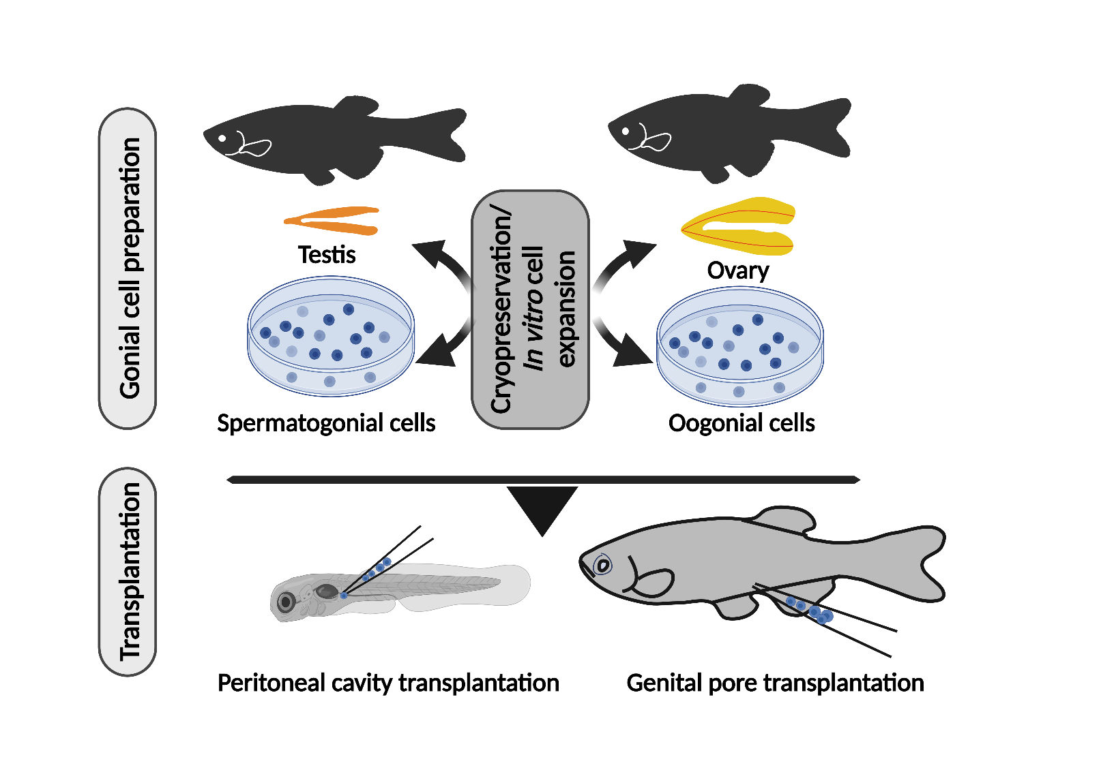

Figure 4. An overview of gonial cell transplantation. This figure is created using Biorender.com.

    - Germ cell depletion techniques
Germ cell depletion is a prerequisite for surrogate production. Induced sterilization of the host is performed at different developmental stages, depending on the techniques, to ensure the complete removal of the endogenous gem cells before introducing the donor germ cells into their gonad. The germ cell-free gonad of the recipient supports colonization of the transplanted donor germ cells and thereby produces gametes from the donor origin. Besides the genetic compatibility and the translatability of donor germ cells, host sterility is another crucial factor that contributes to germline chimera production efficiency. Various methods have been developed recently and optimized for well-known species like zebrafish, medaka, rainbow trout, and sturgeons. In this section, the author discusses different sterilization methods and outlines their limitations.

Gene knockdown and knockout –
Silencing the genes essential for germ cell formation and survival at the early developmental stages (one/two-cell stage embryo) can efficiently induce sterility in the recipient. The most commonly used technique for gene knockdown is morpholino antisense oligonucleotide (MO), designed to target the pre-mature or mature mRNA of the gene of interest to prevent mRNA splicing and translation, respectively. In contrast, gene knockout uses the genome editing tool, for example, the CRIPSR-Cas9 system or TALEN, to prevent transcription of the target gene by modifying the target gene sequence (Wargelius et al., 2016; Baloch et al., 2019). Both techniques require microinjection at the early stage of embryogenesis before the gonad formation. However, these techniques are useful when the species genome information is well known. Dead-end and nanos1 are well-known genes targeted in zebrafish and medaka for sterility induction (Ciruna et al., 2002a; Saito et al., 2010; Li et al., 2016). Gene knockdown by MO targeting dnd1 mRNA is also utilized in this thesis, and the method is explained in detail in Chapters 2 and 3. Designing MO for translation inhibition and the target sequence for gene modification demands the precise and unique sequence of the target gene, failing which may lead to off-target effect and aberrant phenotype development in the recipient. While germ cell depletion is highly efficient and reliable using these strategies (Franěk et al., 2022), the short window for injection into one to two-cell stage embryos and their survival rate post-injection poses a challenge for large-scale sterile recipient production. In addition, availing nucleotide sequence information for some unknown species and embryos that are not amenable to genetic manipulation could utilize other methods described below for sterility induction.

Chromosomal manipulation –
Production of triploid by second polar body retention may induce sterility in some species. This method needs optimization for every species. Triploidy induction refers to the production of individuals with three sets of homologous chromosomes and can be induced in fish by inhibiting the second meiotic division followed by the extrusion of the second polar body (Oliveira et al., 1995; Cuñado et al., 2002). Triploid induction is achieved by heat, cold shock, or hydrostatic pressure immediately after fertilization. The duration and the mode of shock vary between species. Triploids usually have underdeveloped gonads lacking post-meiotic germ cells (Franěk et al., 2019b). Some triploid species produce a small amount of spermatozoa that are aneuploid and abnormal (Takeuchi et al., 2018). This strategy is useful for the species that are difficult for genetic manipulation or microinjection. Several hundreds of recipients can be generated for large-scale germ cell transplantation, but the incorporation of the donor germ cells post-transplantation may be a challenge because the presence of endogenous germ cells may outcompete donor germ cells, thereby reducing the incorporation efficiency.

Hybridization –
Interspecies hybridization between two closely related species sometimes produces sterile offspring that can be used for surrogate production. Cross-breeding between two different species affects sterility in several ways. Some hybrids possess well-developed gonads mostly occupied with oogonia or spermatogonia (Hamaguchi and Sakaizumi, 1992), reported to be caused by aberrant homologous recombination during meiosis, and some hybrids contain gonads that are underdeveloped and thread-like structures with no germ cells. It is reported to be caused by the mitotic arrest of PGC. (Yoshikawa et al., 2018). However, not all cross-breed individuals are sterile. Hybrids produced by in vitro fertilization of female zebrafish and male pearl danio are reportedly sterile, and the same protocol has been applied in Chapter 3 of this thesis to produce recipients for surrogate production (Wong et al., 2011). In addition, interspecific hybrids between other species have been successfully used for germ cell transplantation (Kawamura et al., 2020; Xu et al., 2020). The drawback of these methods is the transplantation efficiency due to the presence of meiotic arrested germ cells that can significantly affect the growth and proliferation of donor germ cells and reduce the production of functional donor-derived gametes, which is thoroughly discussed in Chapter 3 using high-throughput whole genome bisulfite sequencing.

Chemical and radiation treatment –
UV radiation is reported for sterility induction in the endangered sturgeon species. Sturgeon embryos are sensitive to micromanipulation and MO treatment, hence resulting in high mortality post-injection. UV irradiation of the vegetal pole of the sturgeon embryo, where the germplasm is located, is shown to induce sterility (Saito et al., 2018).
Sterilization by chemical treatment is the least popular method in fish and is performed in sexually competent adult fish. The most common method is the injection of a cytostatic drug, busulfan, directly into the genital papilla of adults with a combination of high temperatures at an optimum dose (Majhi et al., 2009; Nóbrega et al., 2010; Lacerda et al., 2010). Busulfan interferes with cell proliferation and causes endogenous germ cell degeneration. However, this method fails to remove all the germ cells, and a high dosage of busulfan is toxic to the cells. In addition, this treatment is only possible in sexually competent fish and is not promising for xenogenic transplantation (Goto and Saito, 2019). Allogenic transplantation, where the immune rejection of donor germ cells is less likely, may use busulfan to produce a large number of recipients.

  - Epigenetic changes associated with germ-cell-based biotechnologies

Epigenetics refers to processes that result in heritable alterations in gene activity
without manipulating the underlying DNA sequence (Jablonka and Lamb, 2002). Handling the donor germ cell during enzymatic or mechanical cell isolation from the intact tissue and their proliferation in the host gonad post-transplantation may disturb the original epigenetic makeup of the donor germline. Epigenetics is the well-known regulator of gene expression through DNA methylation, histone modification, and non-coding RNAs. Surrogate production technologies involve many systematic procedures that may lead to the remodelling of the epigenome in the donor germline, a caveat of germ cell transplantation that questions its practical reliability. The perturbed epigenome may induce phenotypical anomalies that can be potentially inherited by future generations produced via surrogates, also known as intergenerational for the transient or transgenerational inheritance for prolonged maintenance of inherited epigenetic marks. Epigenetics modifications remain to be unfolded in donor-derived gametes produced by surrogate broodstocks. In fish, epigenetics reprogramming is best studied in zebrafish (Jiang et al., 2013; Potok et al., 2013; Skvortsova et al., 2019) and medaka (Oryzias latipes) (Wang and Bhandari, 2020) during embryonic development. In medaka, PGCs undergo DNA methylation and histone marks reprogramming like mice and humans, and almost all epigenetic marks are discarded (Wang and Bhandari, 2020). On the contrary, the zebrafish germline lacks epigenetic reprogramming post-fertilization and preserves paternal epigenetic marks from 4−36 h post-fertilization (Skvortsova et al., 2019). However, the information on later developmental stages is still unknown. Considering theses current findings, it is thoughtworthy to consider evaluating the environmental or chemical stressors that induce epigenetic changes in the germline during the window of germ cell isolation, proliferation, and differentiation in the host gonad using zebrafish as a model. In addition to GCT, it is also crucial to know how different surrogates are treated with varying methods of sterilization, how their phylogenetic distance/the degree of genetic compatibility can influence the epigenome, and to what extent.

The aims of the thesis
The presented thesis aimed to explore the compatibility between foreign germline cells and gonadal somatic cells of species from different genera to produce germline chimera with enhanced features, focusing mainly on fecundity with a new species, giant danio (Devario aequipinnatus). The effort is made to understand the deeper level of genetic information changes associated with the surrogate production technique resulting from the recipient gonadal microenvironment interaction with the donor germ cell using two well-known freshwater species, zebrafish and pearl danio, which may provide a new perspective on surrogate production and its application in aquaculture.

The specific objectives of the thesis were the following:

- Optimization of germ cell transplantation technique to produce a big-body sized surrogate for zebrafish with comparatively higher fecundity and assessing the sexual phenotype of sterile giant danio recipient in order to check the possibility of producing zebrafish donor-derived oocyte.
- A thorough exploration of the epigenetic perturbation and their intergenerational inheritance effect caused by germ cell manipulation and their development in the foreign environment of the recipient gonad in both intra- and interspecific surrogates with single base-resolution whole genome bisulfite sequencing.
- Development of a unique method to harvest viable germ cells from the donor for transplantation without comprising their survival and reproductive output using two small species, zebrafish and killifish (Nothobranchius furzeri).

Reference

Baloch, A.R., Franěk, R., Tichopád, T., Fucíková, M., Rodina, M., Pšenicka, M., 2019. Dnd1 Knockout in sturgeons by CRISPR/Cas9 generates germ cell Free host for surrogate production. Animals. 9,174.
Ciruna, B., Weidinger, G., Knaut, H., Thisse, B., Thisse, C., Raz, E., Schier, A.F., 2002. Production of maternal-zygotic mutant zebrafish by germ-line replacement. Proc. Natl. Acad. Sci. U. S. A. 99, 14919–14924.
Cuñado, N., Terrones, J., Sánchez, L., Martínez, P., Santos, J.L., 2002. Sex-dependent synaptic behaviour in triploid turbot, Scophthalmus maximus (Pisces, Scophthalmidae). Heredity. 89, 460–464.
Devlin, R.H., Nagahama, Y., 2002. Sex determination and sex differentiation in fish: an overview of genetic, physiological, and environmental influences. Aquaculture. 208, 191–364.
Doitsidou, M., Reichman-Fried, M., Stebler, J., Köprunner, M., Dörries, J., Meyer, D., Esguerra, C. V., Leung, T.C., Raz, E., 2002. Guidance of primordial germ cell migration by the chemokine SDF-1. Cell. 111, 647–659.
Franěk, R., Cheng, Y., Fučíková, M., Kašpar, V., Xie, X., Shah, M.A., Linhart, O., Šauman, I., Pšenička, M., 2022. Who is the best surrogate for germ stem cell transplantation in fish? Aquaculture. 549, 737759.
Franěk, R., Kašpar, V., Shah, M.A., Gela, D., Pšenička, M., 2021. Production of common carp donor-derived offspring from goldfish surrogate broodstock. Aquaculture. 534, 736252.
Franěk, R., Marinović, Z., Lujić, J., Urbányi, B., Fučíková, M., Kašpar, V., Pšenička, M., Horváth, Á., 2019a. Cryopreservation and transplantation of common carp spermatogonia. PLoS One. 14, 1–17.
Franěk, R., Tichopád, T., Fučíková, M., Steinbach, C., Pšenička, M., 2019b. Production and use of triploid zebrafish for surrogate reproduction. Theriogenology. 140, 33–43.
Goto, R., Saito, T., 2019. A state-of-the-art review of surrogate propagation in fish. Theriogenology. 133, 216–227.
Hamaguchi, S., Sakaizumi, M., 1992. Sexually differentiated mechanisms of sterility in interspecific hybrids between Oryzias latipes and O. curvinotus. J. Exp. Zool. 263, 323–329.
Hattori, R.S., Yoshinaga, T.T., Katayama, N., Hattori-Ihara, S., Tsukamoto, R.Y., Takahashi, N.S., Tabata, Y.A., 2019. Surrogate production of Salmo salar oocytes and sperm in triploid Oncorhynchus mykiss by germ cell transplantation technology. Aquaculture. 506, 238–245.
Ichida, K., Hayashi, M., Miwa, M., Kitada, R., Takahashi, M., Fujihara, R., Boonanuntanasarn, S., Yoshizaki, G., 2019. Enrichment of transplantable germ cells in salmonids using a novel monoclonal antibody by magnetic-activated cell sorting. Mol. Reprod. Dev. 86, 1810–1821.
Iwasaki-Takahashi, Y., Shikina, S., Watanabe, M., Banba, A., Yagisawa, M., Takahashi, K., Fujihara, R., Okabe, T., Valdez, D.M., Yamauchi, A., Yoshizaki, G., 2020. Production of functional eggs and sperm from in vitro-expanded type A spermatogonia in rainbow trout. Commun. Biol. 3, 308.
Jablonka, E., Lamb, M.J., 2002. The changing concept of epigenetics. Ann. N. Y. Acad. Sci. 981, 82–96.
Jiang, L., Zhang, Jing, Wang, J.J., Wang, L., Zhang, L., Li, G., Yang, X., Ma, X., Sun, X., Cai, J., Zhang, Jun, Huang, X., Yu, M., Wang, X., Liu, F., Wu, C.I., He, C., Zhang, B., Ci, W., Liu, J., 2013. Sperm, but not oocyte, DNA methylome is inherited by zebrafish early embryos. Cell. 153, 773–784.
Kawakami, Y., Goto-Kazeto, R., Saito, T., Fujimoto, T., Higaki, S., Takahashi, Y., Arai, K., Yamaha, E., 2010. Generation of germ-line chimera zebrafish using primordial germ cells isolated from cultured blastomeres and cryopreserved embryoids. Int. J. Dev. Biol. 54, 1493–1501.
Kawamura, W., Tani, R., Yahagi, H., Kamio, S., Morita, T., Takeuchi, Y., Yazawa, R., Yoshizaki, G., 2020. Suitability of hybrid mackerel (Scomber australasicus × S. japonicus) with germ cell-less sterile gonads as a recipient for transplantation of bluefin tuna germ cells. Gen. Comp. Endocrinol. 295.
Kise, K., Yoshikawa, H., Sato, M., Tashiro, M., Yazawa, R., Nagasaka, Y., Takeuchi, Y., Yoshizaki, G., 2012. Flow-cytometric isolation and enrichment of teleost type A spermatogonia based on light-scattering properties. Biol. Reprod. 86, (4)1–12.
Kobayashi, T., Yoshizaki, G., Takeuchi, Y., Takeuchi, T., 2004. Isolation of highly pure and viable primordial germ cells from rainbow trout by GFP-dependent flow cytometry. Mol. Reprod. Dev. 67, 91–100.
Köprunner, M., Thisse, C., Thisse, B., Raz, E., 2001. A zebrafish nanos-related gene is essential for the development of primordial germ cells. Genes Dev. 15, 2877–2885.
Kurokawa, H., Aoki, Y., Nakamura, S., Ebe, Y., Kobayashi, D., Tanaka, M., 2006. Time-lapse analysis reveals different modes of primordial germ cell migration in the medaka Oryzias latipes. Dev. Growth Differ. 48, 209–221.
Lacerda, S.M.S.N., Batlouni, S.R., Costa, G.M.J., Segatelli, T.M., Quirino, B.R., Queiroz, B.M., Kalapothakis, E., França, L.R., 2010. A new and fast technique to generate offspring after germ cell transplantation in adult fish: The Nile Tilapia (Oreochromis niloticus) Model. PLoS One. 5, e10740.
Lee, S., Iwasaki, Y., Shikina, S., Yoshizaki, G., 2013. Generation of functional eggs and sperm from cryopreserved whole testes. Proc. Natl. Acad. Sci. U. S. A. 110, 1640–1645.
Li, M., Hong, N., Xu, H., Song, J., Hong, Y., 2016. Germline replacement by blastula cell transplantation in the fish medaka. Sci. Rep. 6, 1–10.
Liew, W.C., Bartfai, R., Lim, Z., Sreenivasan, R., Siegfried, K.R., Orban, L., 2012. Polygenic sex determination system in zebrafish. PLoS One. 7, e34397.
Liew, W.C., Orbán, L., 2014. Zebrafish sex: a complicated affair. Brief. Funct. Genomics. 13, 172–187.
Lubzens, E., Young, G., Bobe, J., Cerdà, J., 2010. Oogenesis in teleosts: How fish eggs are formed. Gen. Comp. Endocrinol. 165, 367–389.
Maegawa, S., Fujimoto, T., Saito, T., Inoue, K., Tanaka, M., Arai, K., Yamaha, E., 2002. Visualization of primordial germ cells in vivo using GFP-nos1-3’UTR mRNA. Int. J. Dev. Biol. 50, 691–700.
Mahabaleshwar, H., Boldajipour, B., Raz, E., 2008. Killing the messenger. Cell Adh. Migr. 2, 69–70.
Majhi, S.K., Hattori, R.S., Rahman, S.M., Suzuki, T., Strüssmann, C.A., 2009. Experimentally induced depletion of germ cells in sub-adult Patagonian pejerrey (Odontesthes hatcheri). Theriogenology. 71, 1162–1172.
Morita, T., Miwa, M., Kumakura, N., Morishima, K., Miki, T., Takeuchi, Y., Yoshizaki, G., 2021. Production of functional sperm from cryopreserved testicular germ cells following intraperitoneal transplantation into allogeneic surrogate in yellowtail (Seriola quinqueradiata). Cryobiology. 100, 32–39.
Morita, T., Morishima, K., Miwa, M., Kumakura, N., Kudo, S., Ichida, K., Mitsuboshi, T., Takeuchi, Y., Yoshizaki, G., 2015. Functional sperm of the yellowtail (Seriola quinqueradiata) were produced in the small-bodied surrogate, Jack Mackerel (Trachurus japonicus). Mar. Biotechnol. 17, 644–654.
Nóbrega, R.H., Greebe, C.D., van de Kant, H., Bogerd, J., de França, L.R., Schulz, R.W., 2010. Spermatogonial stem cell niche and spermatogonial stem cell transplantation in zebrafish. PLoS One. 5, e12808.
Okutsu, T., Suzuki, K., Takeuchi, Y., Takeuchi, T., Yoshizaki, G., 2006a. Testicular germ cells can colonize sexually undifferentiated embryonic gonad and produce functional eggs in fish 103, 4–5.
Oliveira, C., Foresti, F., Rigolino, M.G., Tabata, Y.A., 1995. Synaptonemal complex formation in spermatocytes of the autotriploid rainbow trout, Oncorhynchus mykiss (Pisces, Salmonidae). Hereditas. 123, 215–220.
Olsen, L.C., Aasland, R., Fjose, A., 1997. A vasa-like gene in zebrafish identifies putative primordial germ cells. Mech. Dev. 66, 95–105.
Panda, R.P., Barman, H.K., Mohapatra, C., 2011. Isolation of enriched carp spermatogonial stem cells from Labeo rohita testis for in vitro propagation. Theriogenology. 76, 241–251.
Potok, M.E., Nix, D.A., Parnell, T.J., Cairns, B.R., 2013. Reprogramming the maternal zebrafish genome after fertilization to match the paternal methylation pattern. Cell. 153, 759–772.
Pšenička, M., Saito, T., Rodina, M., Dzyuba, B., 2016. Cryopreservation of early stage Siberian sturgeon Acipenser baerii germ cells, comparison of whole tissue and dissociated cells. Cryobiology. 72, 119–122.
Raz, E., 2003. Primordial germ-cell development: The zebrafish perspective. Nat. Rev. Genet. 4, 690–700.
Raz, E., 2004. Guidance of primordial germ cell migration. Curr. Opin. Cell Biol. 16, 169–173.
Ren, Y., Sun, Z., Wang, Y., Yu, Q., Wang, G., He, Z., Liu, Y., Jiang, X., Kang, X., Hou, J., 2021. Production of donor-derived offsprings by allogeneic transplantation of oogonia in the adult Japanese flounder (Paralichthys olivaceus). Aquaculture. 543, 736977.
Saito, T., Goto-Kazeto, R., Arai, K., Yamaha, E., 2008. Xenogenesis in teleost fish through generation of germ-line chimeras by single primordial germ cell transplantation. Biol. Reprod. 78, 159–166.
Saito, T., Goto-Kazeto, R., Fujimoto, T., Kawakami, Y., Arai, K., Yamaha, E., 2010. Inter-species transplantation and migration of primordial germ cells in cyprinid fish. Int. J. Dev. Biol. 54, 1481–1486.
Saito, T., Güralp, H., Iegorova, V., Rodina, M., Pšeniaka, M., 2018. Elimination of primordial germ cells in sturgeon embryos by ultraviolet irradiation. Biol. Reprod. 99, 556–564.
Schulz, R.W., de França, L.R., Lareyre, J.J., LeGac, F., Chiarini-Garcia, H., Nobrega, R.H., Miura, T., 2010. Spermatogenesis in fish. Gen. Comp. Endocrinol. 165, 390–411.
Silva, M.A., Costa, G.M.J., Lacerda, S.M.S.N., Brandão-Dias, P.F.P., Kalapothakis, E., Silva Júnior, A.F., Alvarenga, E.R., França, L.R., 2016. Successful xenogeneic germ cell transplantation from Jundia catfish (Rhamdia quelen) into adult Nile tilapia (Oreochromis niloticus) testes. Gen. Comp. Endocrinol. 230–231, 48–56.
Skvortsova, K., Tarbashevich, K., Stehling, M., Lister, R., Irimia, M., Raz, E., Bogdanovic, O., 2019. Retention of paternal DNA methylome in the developing zebrafish germline. Nat. Commun. 10, 3054.
Takeuchi, Y., Yatabe, T., Yoshikawa, H., Ino, Y., Kabeya, N., Yazawa, R., Yoshizaki, G., 2018. Production of functionally sterile triploid Nibe croaker Nibea mitsukurii induced by cold-shock treatment with special emphasis on triploid aptitude as surrogate broodstock. Aquaculture. 494, 45–56.
Takeuchi, Y., Yoshizaki, G., Takeuchi, T., 2004. Surrogate broodstock produces salmonids. Nat. 430, 629–630.
Takeuchi, Y., Yoshizaki, G., Takeuchi, T., 2003. Generation of live fry from intraperitoneally transplanted primordial germ cells in rainbow trout. Biol. Reprod. 69, 1142–1149.
Tzung, K.W., Goto, R., Saju, J.M., Sreenivasan, R., Saito, T., Arai, K., Yamaha, E., Hossain, M.S., Calvert, M.E.K., Orbán, L., 2015. Early depletion of primordial germ cells in zebrafish promotes testis formation. Stem Cell Reports. 4, 61–73.
Uchida, D., Yamashita, M., Kitano, T., Iguchi, T., 2002. Oocyte apoptosis during the transition from ovary-like tissue to testes during sex differentiation of juvenile zebrafish. J. Exp. Biol. 205, 711–718.
Van De Lavoir, M.C., Diamond, J.H., Leighton, P.A., Mather-Love, C., Heyer, B.S., Bradshaw, R., Kerchner, A., Hooi, L.T., Gessaro, T.M., Swanberg, S.E., Delany, M.E., Etches, R.J., 2006. Germline transmission of genetically modified primordial germ cells. Nat. 441, 766–769.
Wang, X., Bhandari, R.K., 2020. The dynamics of DNA methylation during epigenetic reprogramming of primordial germ cells in medaka (Oryzias latipes). Epigenetics. 15, 483–498.
Wang, X., Zhu, J., Wang, H., Deng, W., Jiao, S., Wang, Y., He, M., Zhang, F., Liu, T., Hao, Y., Ye, D., Sun, Y., 2023. Induced formation of primordial germ cells from zebrafish blastomeres by germplasm factors. Nat. Commun. 14, 7918.
Wargelius, A., Leininger, S., Skaftnesmo, K.O., Kleppe, L., Andersson, E., Taranger, G.L., Schulz, R.W., Edvardsen, R.B., 2016. Dnd knockout ablates germ cells and demonstrates germ cell independent sex differentiation in Atlantic salmon. Sci. Reports. 61 (6), 1–8.
Weidinger, G., Wolke, U., Köprunner, M., Klinger, M., Raz, E., 1999. Identification of tissues and patterning events required for distinct steps in early migration of zebrafish primordial germ cells. Development. 126, 5295–5307.
Wong, T.T., Saito, T., Crodian, J., Collodi, P., 2011. Zebrafish germline chimeras produced by transplantation of ovarian germ cells into sterile host larvae. Biol. Reprod. 84, 1190–1197.
Wylie, C., 1999. Germ Cells. Cell. 96, 165–174.
Xiong, F., Wei, Z.Q., Zhu, Z.Y., Sun, Y.H., 2013. Targeted expression in zebrafish primordial germ cells by Cre/loxP and Gal4/UAS systems. Mar. Biotechnol. 15, 526–539.
Xu, D., Yoshino, T., de Bello Cioffi, M., Yoshikawa, H., Ino, Y., Yazawa, R., dos Santos Nassif Lacerda, S.M., Takeuchi, Y., 2020. Production of donor-derived eggs after ovarian germ cell transplantation into the gonads of adult, germ cell-less, triploid hybrid fish†. Biol. Reprod. 103, 1289–1299.
Xu, H., Li, M., Jianfang, G., Hong, Y., Li, X.H., F, G.J., 2010. Fish germ cells. Sci China Life Sci. 53, 435–446.
Yamaha, E., Murakami, M., Hada, K., Otani, S., Fujimoto, T., Tanaka, M., Sakao, S., Kimura, S., Sato, S., Arai, K., 2003. Recovery of fertility in male hybrids of a cross between goldfish and common carp by transplantation of PGC (primordial germ cell)-containing graft. Genetica. 119, 121–131.
Yamamoto, T.O., 1969. 3 Sex differentiation. Fish Physiol. 3, 117–175.
Yoon, C., Kawakami, K., Hopkins, N., 1997. Zebrafish vasa homologue RNA is localized to the cleavage planes of 2- and 4-cell-stage embryos and is expressed in the primordial germ cells. Development. 124, 3157–3165.
Yoshikawa, H., Xu, D., Ino, Y., Yoshino, T., Hayashida, T., Wang, J., Yazawa, R., Yoshizaki, G., Takeuchi, Y., 2018. Hybrid sterility in fish caused by mitotic arrest of primordial germ cells. Genetics. 209, 507–521.
Yoshizaki, G., Ichikawa, M., Hayashi, M., Iwasaki, Y., Miwa, M., Shikina, S., Okutsu, T., 2010. Sexual plasticity of ovarian germ cells in rainbow trout. Development. 137, 1227–1230.
Yoshizaki, G., Takeuchi, Y., Tominaga, H., Kobayashi, T., Takeuchi, T., 2002. Visualization of primordial germ cells in transgenic rainbow trout carrying green fluorescent protein gene driven by vasa promoter. Fish. Sci. 68, 1067–1070.
Zhang, F., Hao, Y., Li, X., Li, Y., Ye, D., Zhang, R., Wang, X., He, M., Wang, H., Zhu, Z., Sun, Y., 2021. Surrogate production of genome-edited sperm from a different subfamily by spermatogonial stem cell transplantation. Sci. China Life Sci. 65, 969–987.
Zhang, F., Li, X., He, M., Ye, D., Xiong, F., Amin, G., Zhu, Z., Sun, Y., 2020. Efficient generation of zebrafish maternal-zygotic mutants through transplantation of ectopically induced and Cas9/gRNA targeted primordial germ cells. J. Genet. Genomics. 47, 37–47.

Chapter 2

Enhancement of zebrafish sperm production via a large body-sized surrogate with germ cell transplantation

Rigolin Nayak

Nayak, R., Franěk, R., Šindelka, R. et al. Enhancement of zebrafish sperm production via a large body-sized surrogate with germ cell transplantation. Commun Biol 6, 412 (2023).

Papers published in this journal are open access and under the CC-BY Creative Commons attribution license (http://creativecommons.org/licenses/by/4.0/). This means that the author(s) retain copyright and the content is free to download, distribute and adapt for commercial or non-commercial purposes, given appropriate attribution to the original article.

My share of this work is about 70% (manuscript writing, experimental work, and data analyses)
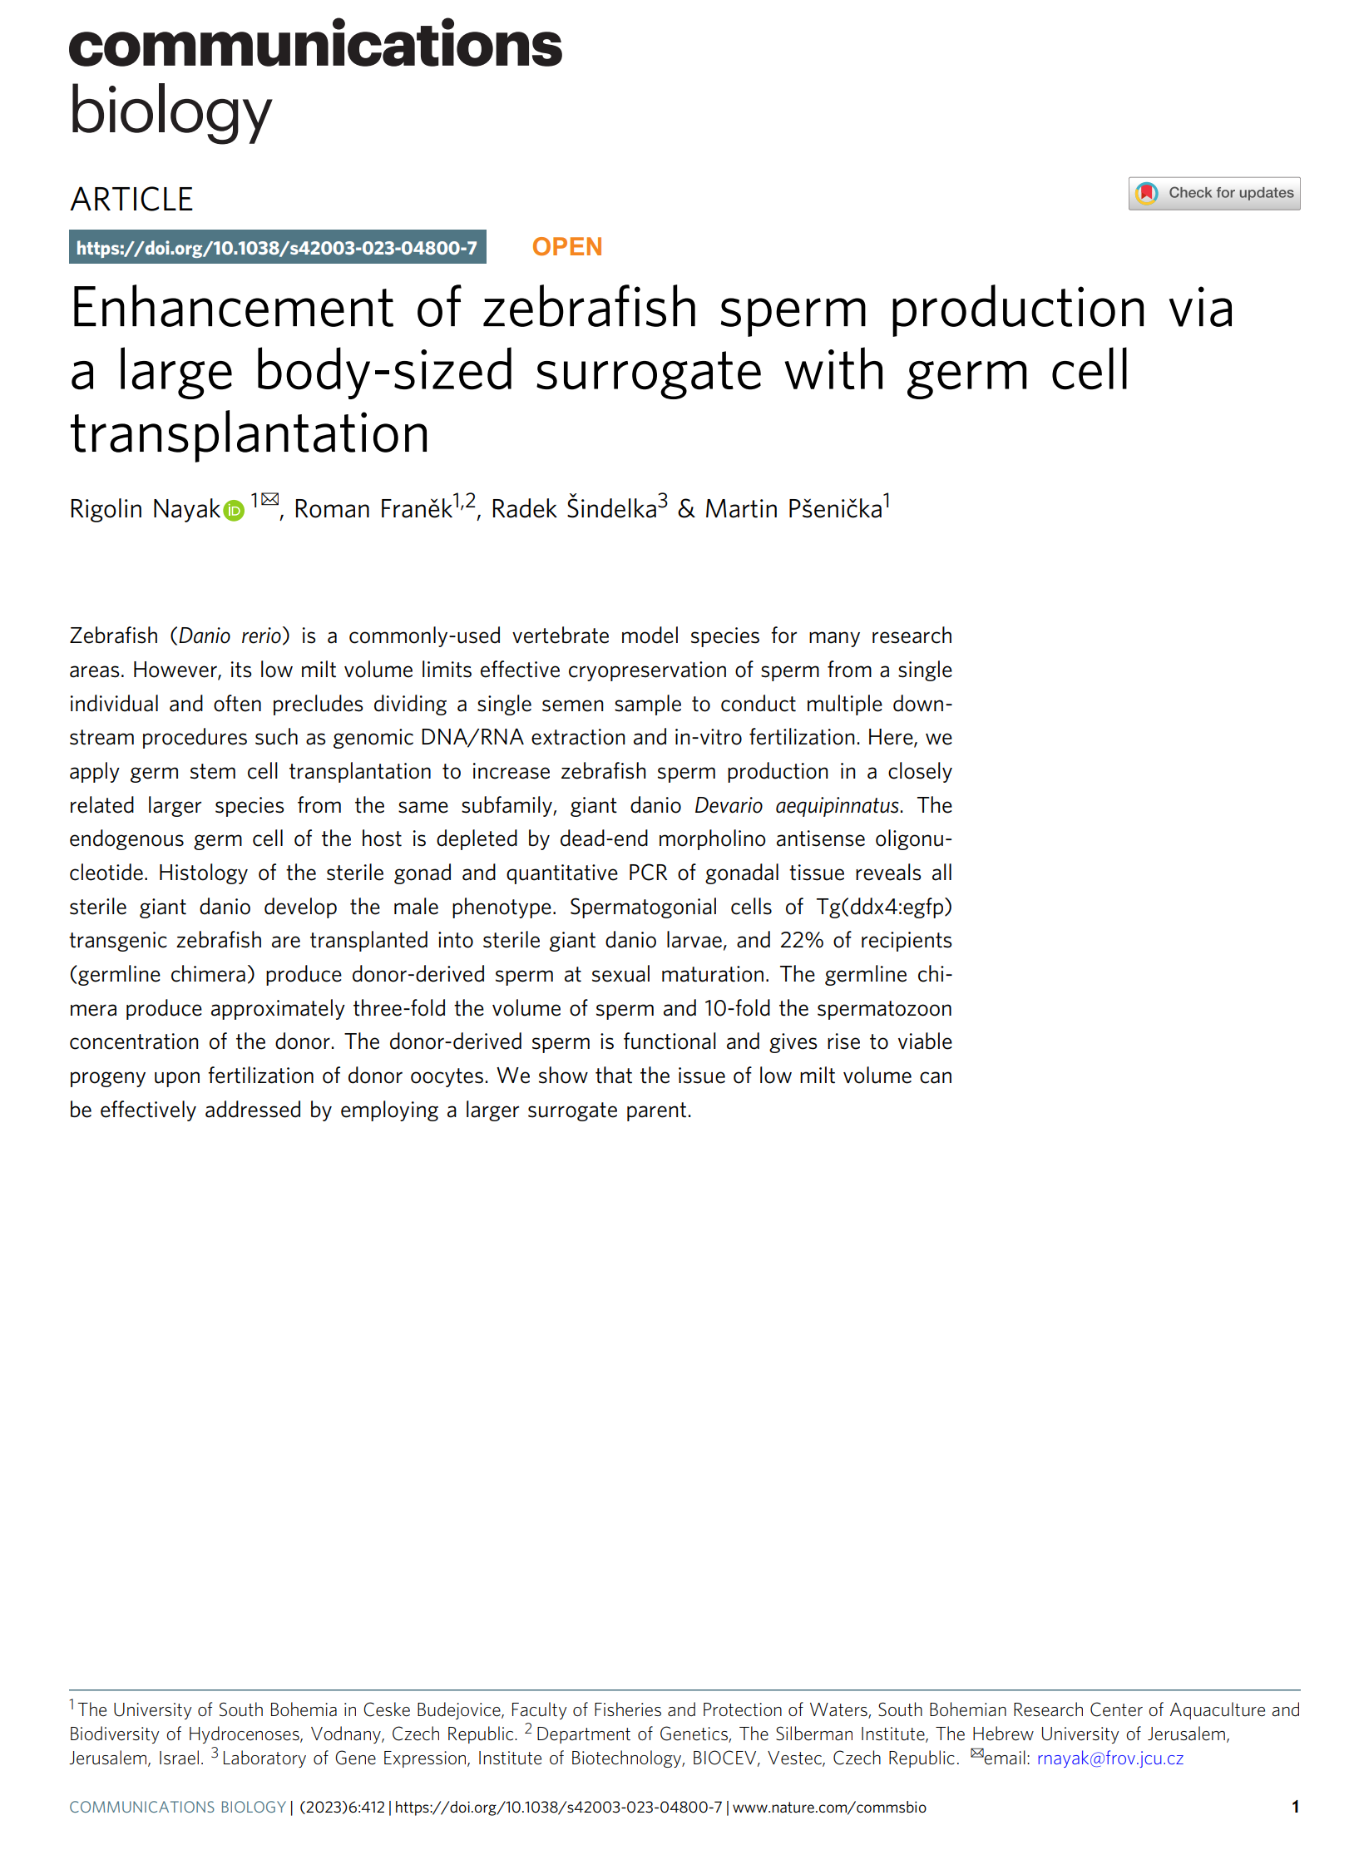
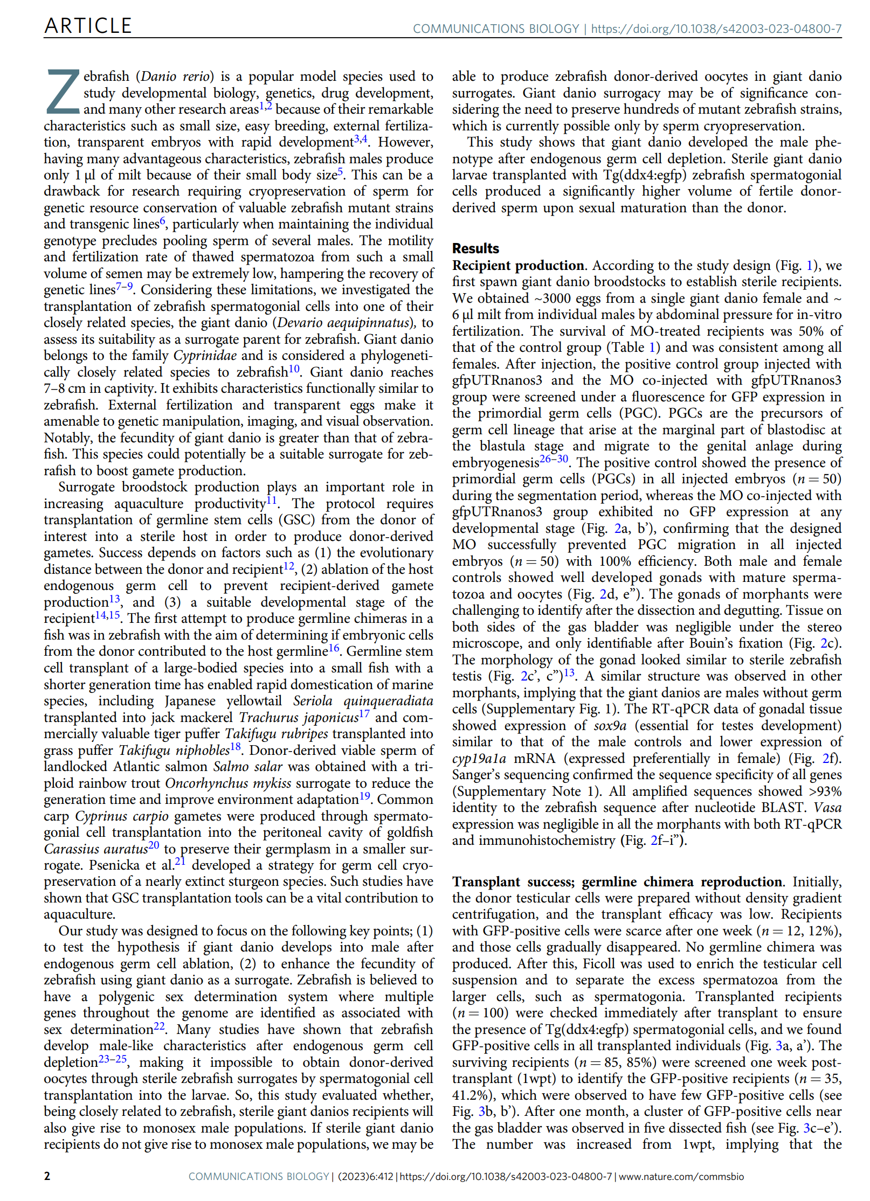
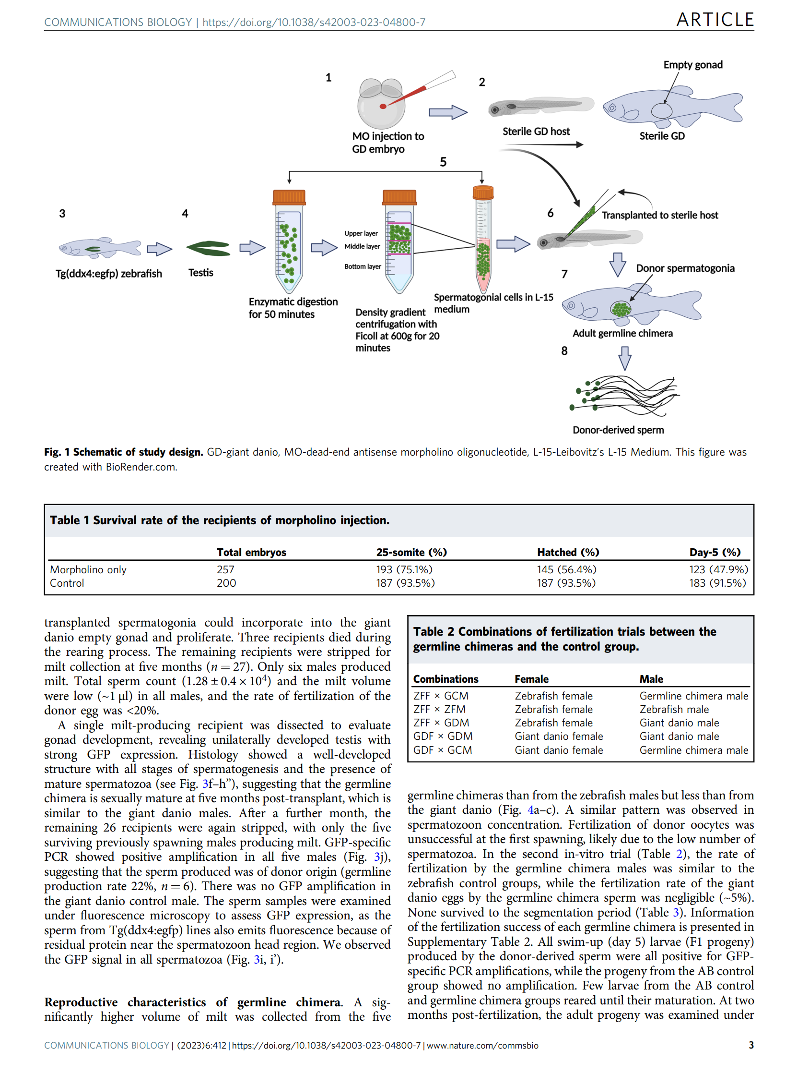
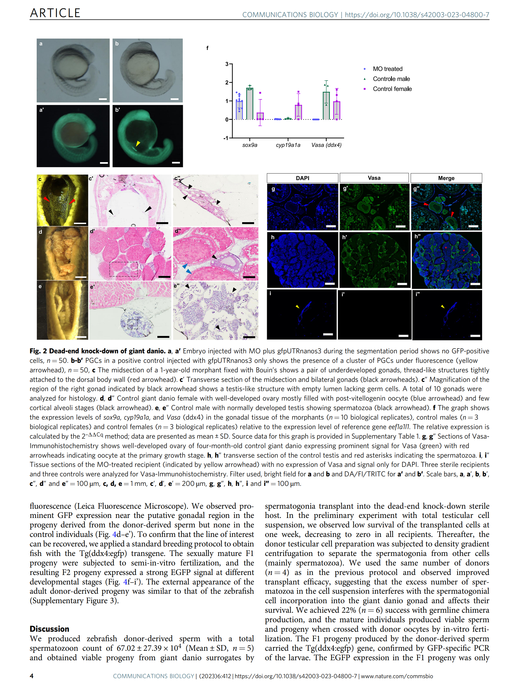
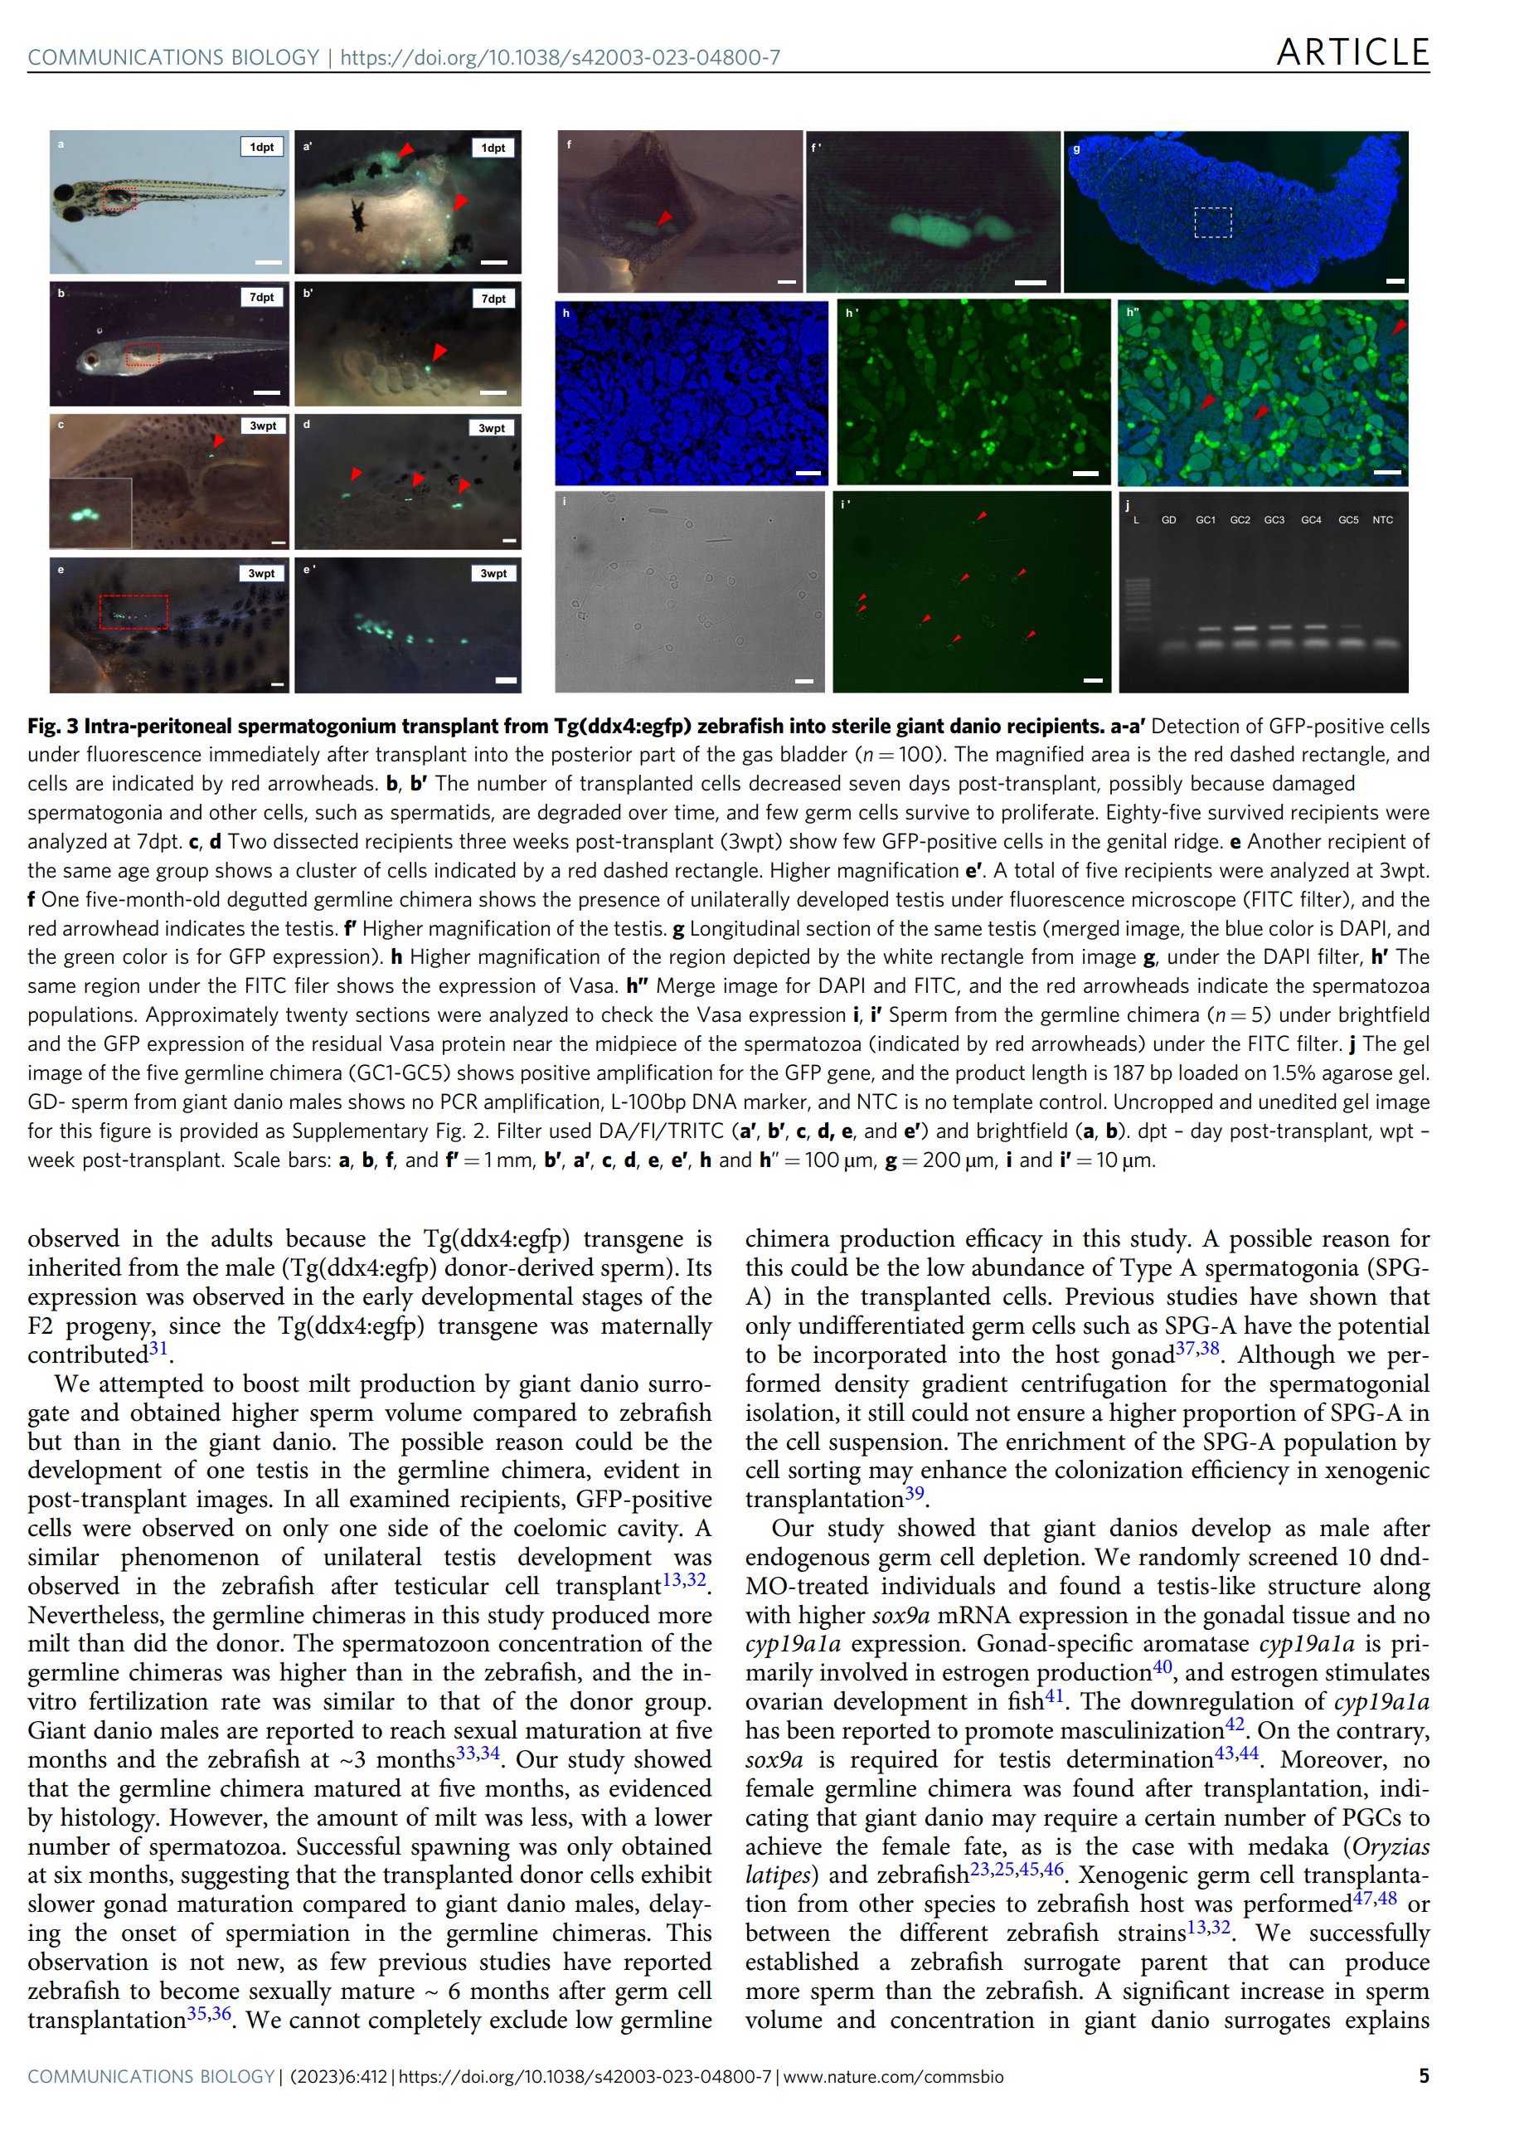
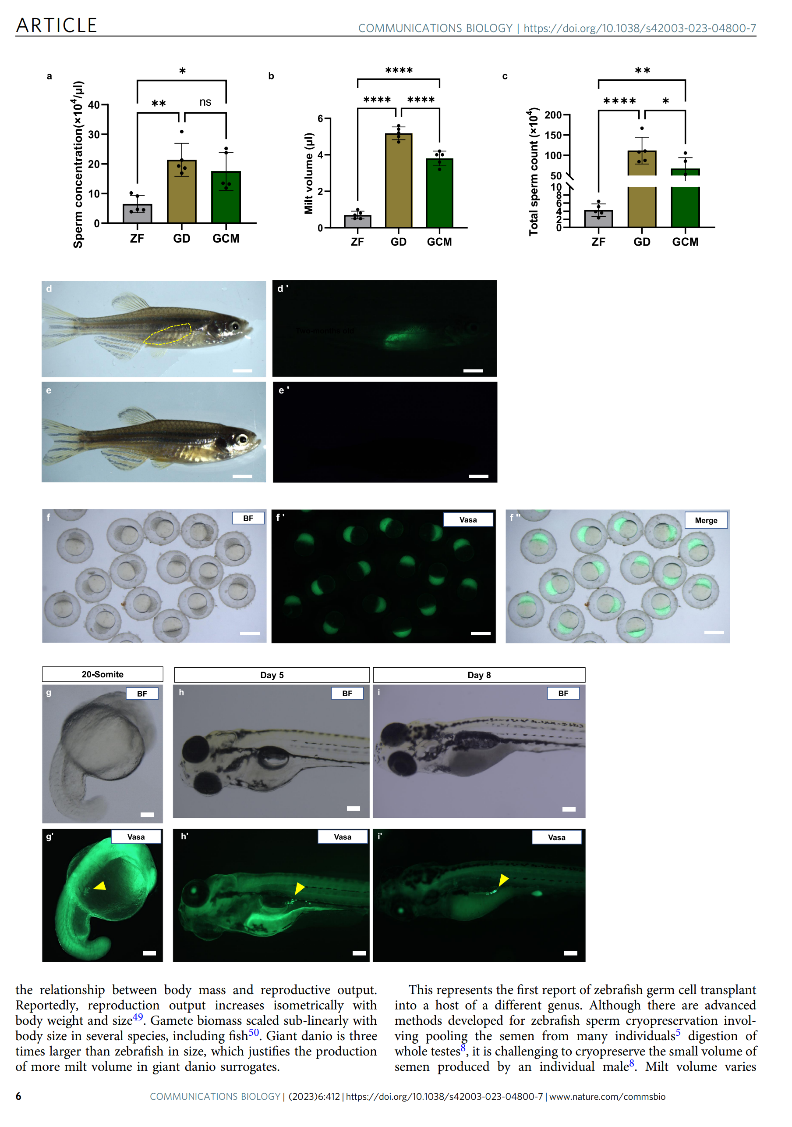
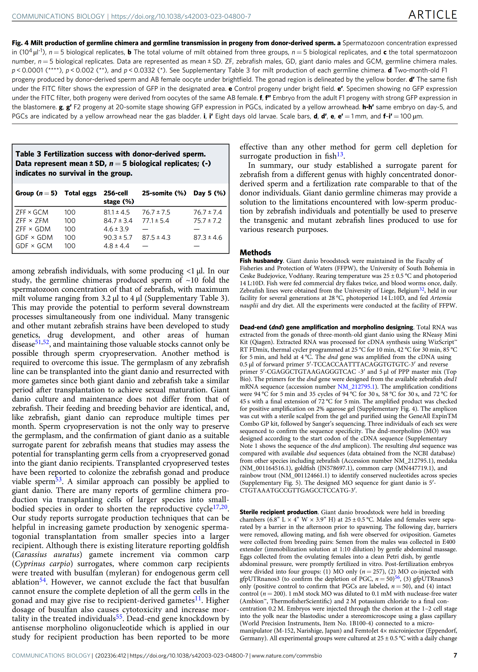
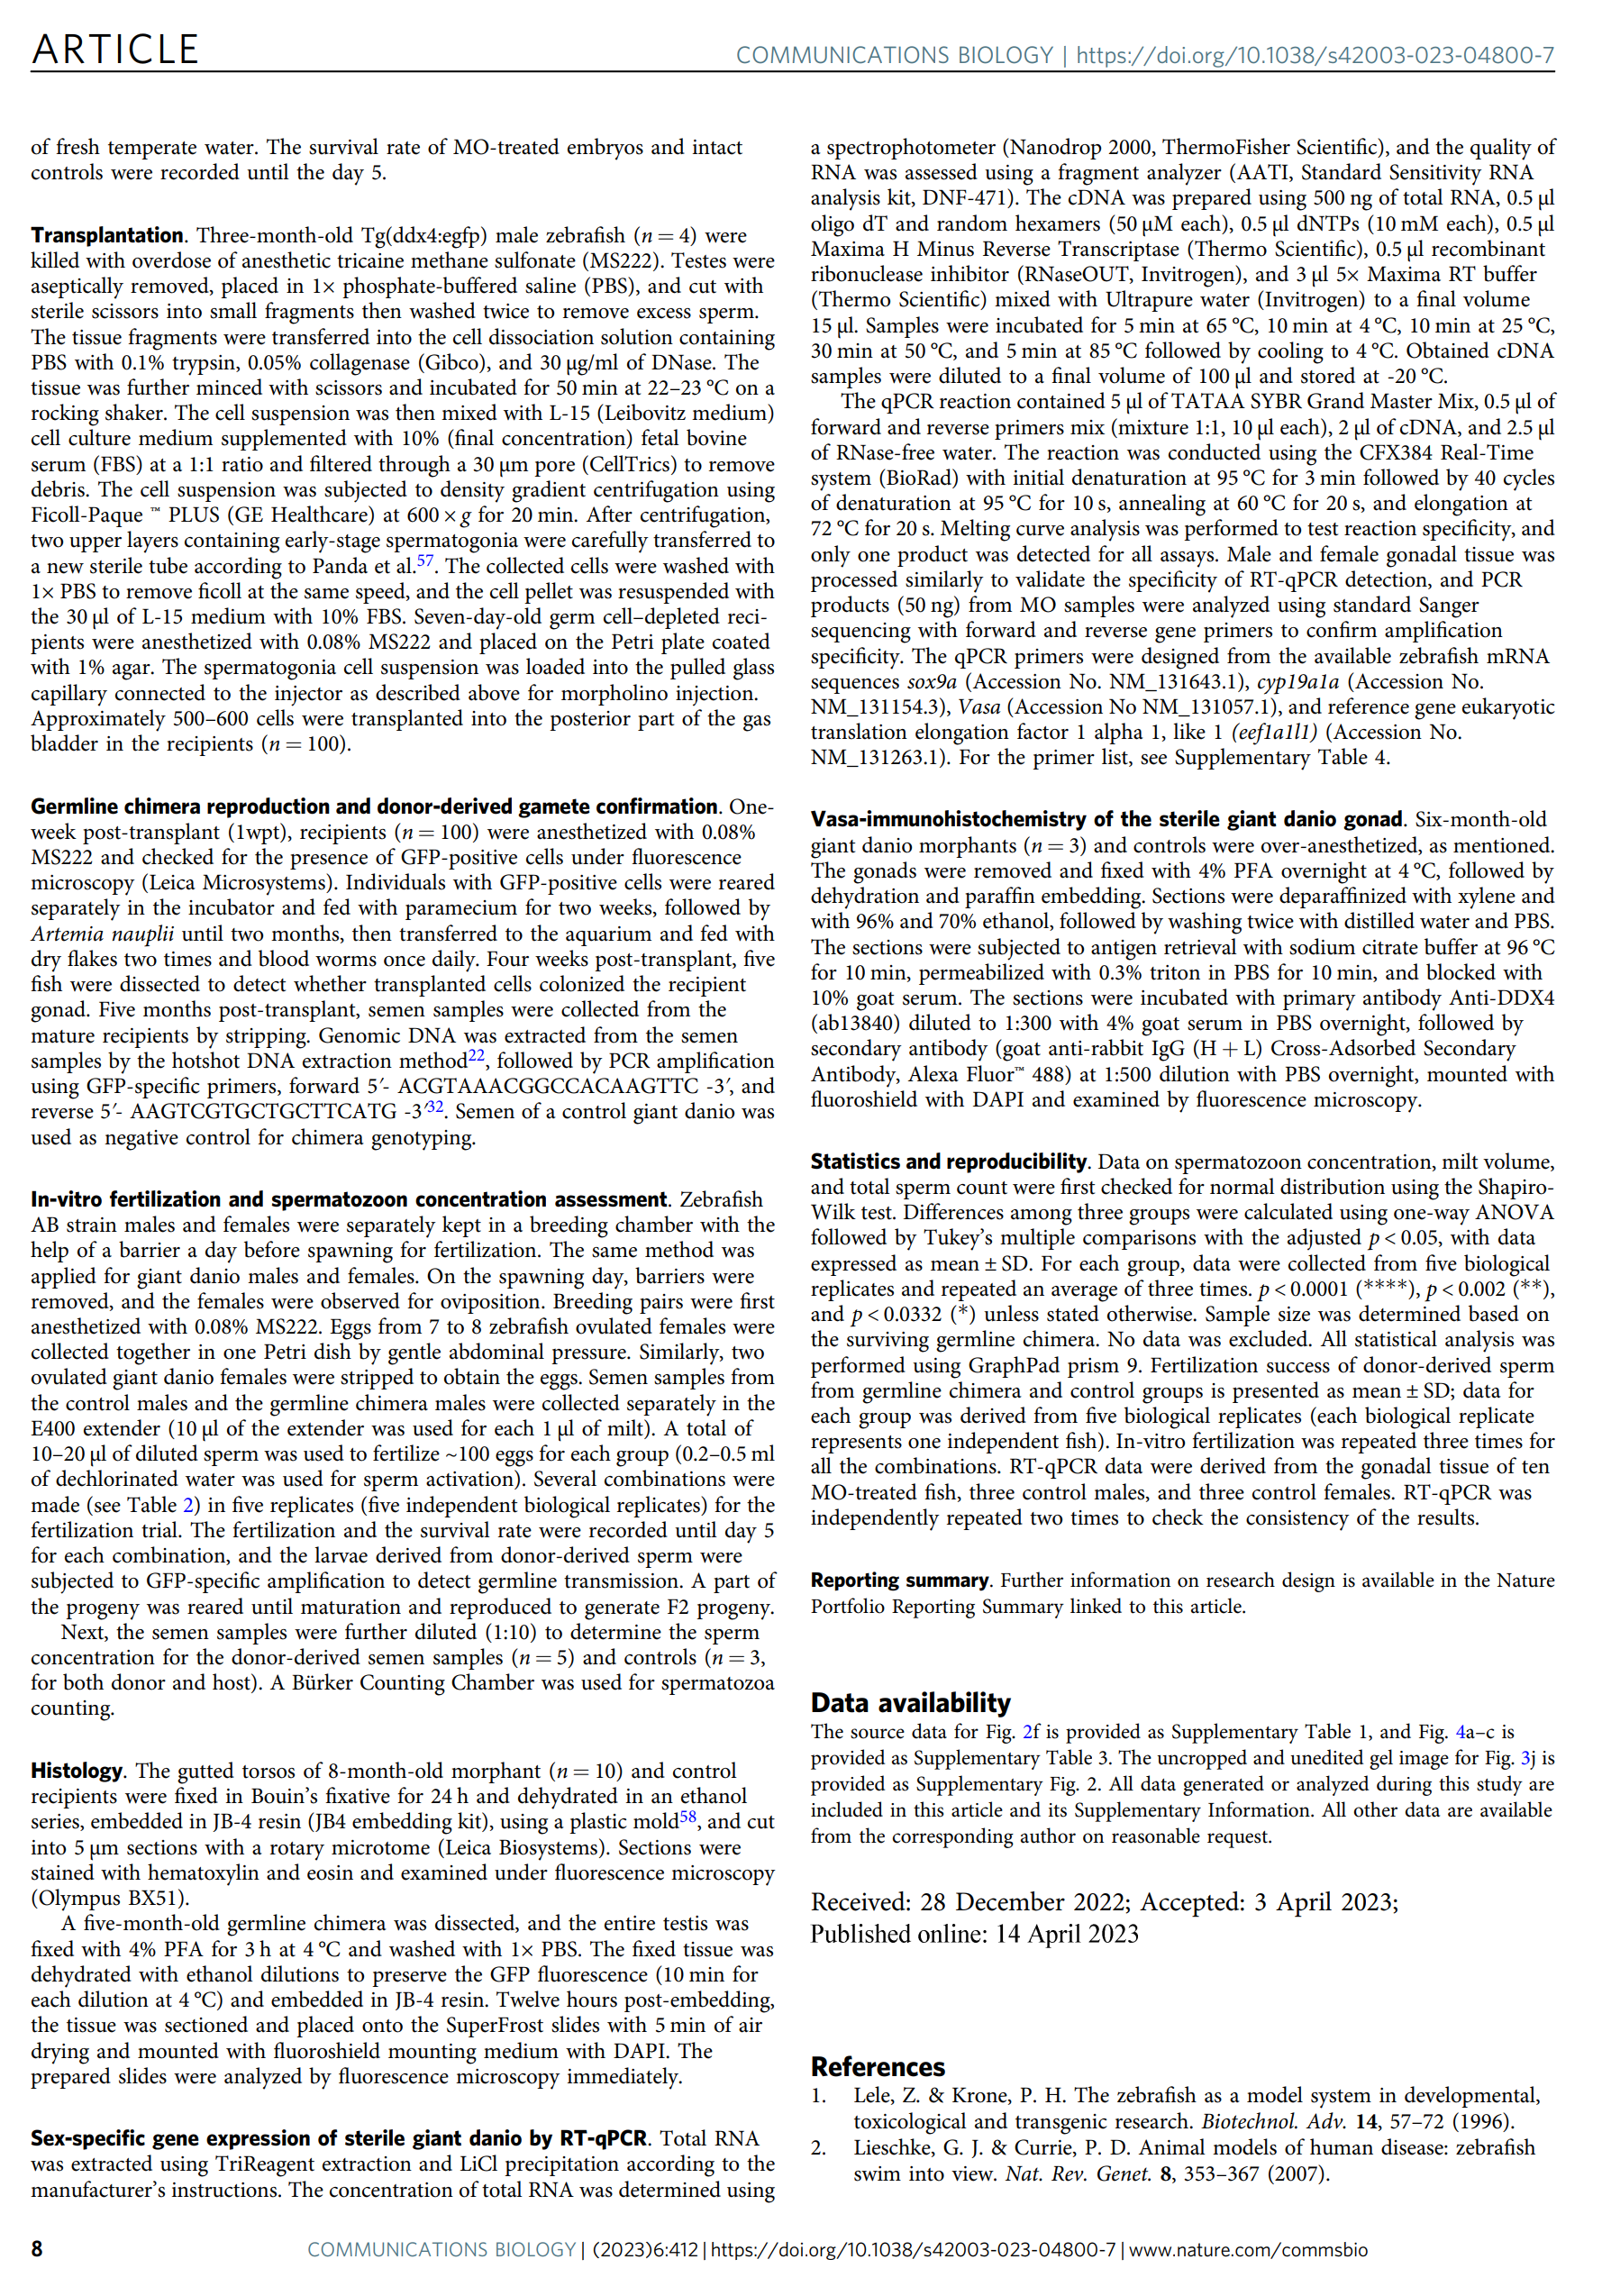
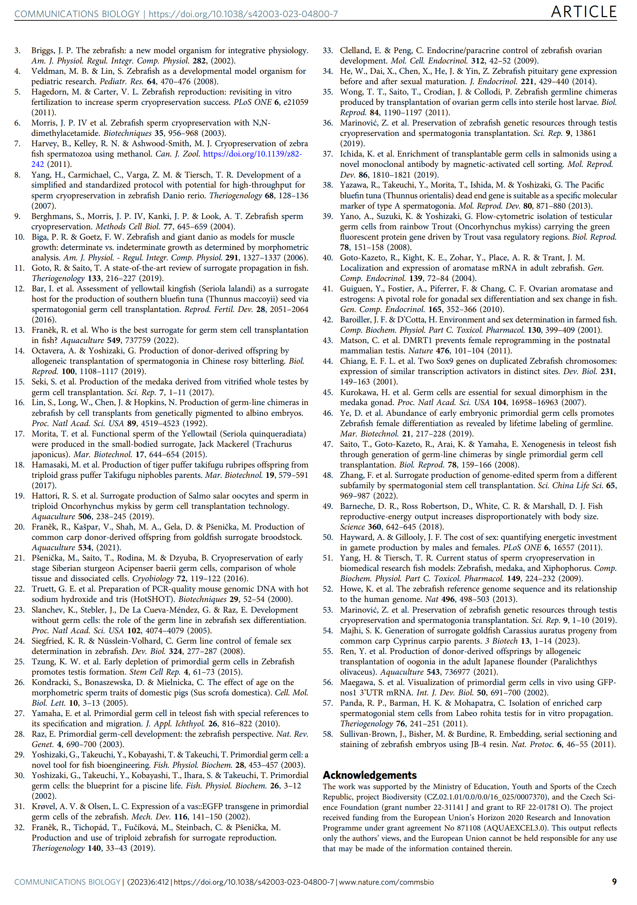
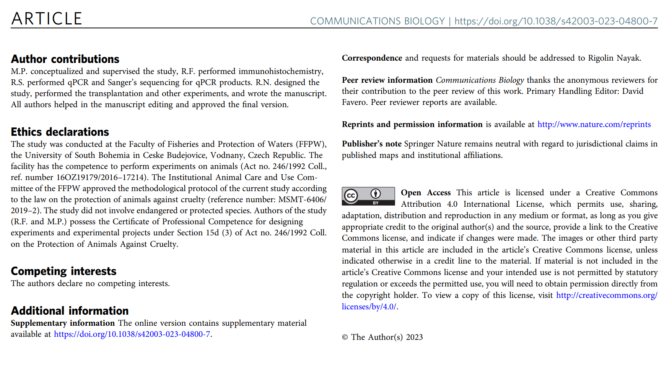

Chapter 3

Genome-wide comparative methylation analysis reveals the fate of germ stem cells after surrogate production in teleost

Rigolin Nayak

Nayak, R., Franěk, R., Laurent, A. et al. Genome-wide comparative methylation analysis reveals the fate of germ stem cells after surrogate production in teleost. BMC Biol 22, 39 (2024).

Papers published in this journal are open access and under the CC-BY Creative Commons attribution license (http://creativecommons.org/licenses/by/4.0/). This means that the author(s) retain copyright and the content is free to download, distribute and adapt for commercial or non-commercial purposes, given appropriate attribution to the original article.

My share of this work is about 70% (manuscript writing, experimental work, and data analyses).
Chapter 4

Partial gonadectomy: A new approach to obtain germline stem cells for transplantation while preserving the donor

Nayak, R., Psenicka, M., Franěk, R.,. Partial gonadectomy: A new approach to obtain germline stem cells for transplantation while preserving the donor. Manuscript

My share on this work is about 70% (manuscript writing, experimental work, and data analyses)
Partial gonadectomy: A new approach to obtain germline stem cells for transplantation while preserving the donor

Rigolin Nayak* ª, Martin Pšenička ª , Roman Franěk ^{a , b}

ªThe University of South Bohemia in Ceske Budejovice, Faculty of Fisheries and Protection of Waters, South Bohemian Research Center of Aquaculture and Biodiversity of Hydrocenoses, Zatisi 728/II, 389 25 Vodnany, Czech Republic.

^{b}Department of Genetics, The Silberman Institute, The Hebrew University of Jerusalem, Jerusalem, Israel.

* Correspondence: rnayak@frov.jcu.cz, franek@frov.jcu.cz
Tel: +420-774202609

Abstract

Surrogacy involves the transplantation of germline stem cells from the donor into the recipient of interest to produce germline chimera. It offers many scopes of restoration of lines from cryopreserved germ stem cells and faster propagation of species with a long maturation time with the help of a surrogate. However, studies reported to date always involved donor sacrificing prior to germ cell collection. Such a practice can significantly hamper the decision of whether surrogacy should be employed as a propagation method for valuable species. Here, we show a non-lethal approach to obtain germline stem cells from adult zebrafish males. We confirm that non-lethally collected spermatogonial cells successfully colonized the recipient gonad and gave rise to donor-derived sperm and, subsequently, viable progeny. Testicular tissue donors showed no mortality after partial gonadectomy in zebrafish. Importantly, their reproductive characteristics were not compromised, and gonads were regenerated. Turquoise killifish males showed no significant differences in their reproductive output compared to the controls post partial gonadectomy. Our study presents robust evidence that surrogate reproduction can be leveraged by partial gonadectomy in small-bodied fish (~0.5 g) while keeping the donor alive and preserving its breeding value. Therefore, we expect that its application in large aquaculture species is feasible and will serve as a viable alternative to the commonly used lethal approach for donor cell collection. Afterward, gonadal tissue donors can still be involved in the breeding cycle while their germ cells are safely stored in liquid nitrogen or propagated through surrogates.

Keywords: Germ cell, transplantation, surrogate production, gonadectomy, zebrafish, turquoise killifish

Introduction

Germline stem cells (GCSs) are the progenitors of gametes. GSCs are bipotent and can transdifferentiate into both sperm and oocyte depending on the sex of the recipient (Okutsu et al., 2006a). The surrogate production approach utilizes this advantage to produce germline chimera in closely related species by transplanting GSCs in the sterile recipient, also known as a surrogate. Germ stem cell transplantation (GCT) in fish is a widely used approach to produce germline chimera for various applications such as genetic resource preservation of threatened species (Lee et al., 2015; Marinović et al., 2019; Franěk et al., 2021), and shortening the generation time (Hamasaki et al., 2017). GCT has been conducted in many species, such as salmonids (Hattori et al., 2019; Iwasaki-Takahashi et al., 2020), sturgeon (Pšenička et al., 2016), cyprinids (Octavera and Yoshizaki, 2019; Franěk et al., 2021), and other marine species (Morita et al., 2015; Yoshikawa et al., 2017; Ren et al., 2021). All studies reported for the GCT have involved sacrificing many donor individuals to isolate the gonad in order to obtain transplantable GSCs. Some species, like Salmonids and sturgeon, are highly valuable and take many years to reach sexual maturation. Sacrificing the whole fish to obtain a few cells each time for transplantation can cause a significant loss of breeding value. In addition, the amount of GSCs required for transplantation depends on the size and number of the recipient larvae. In bigger species like rainbow trout, approximately 5,000 to 15,000 Type-A spermatogonia were reportedly transplanted into each recipient to generate germline chimera (Okutsu et al., 2006a; Lee et al., 2013; Iwasaki-Takahashi et al., 2020), whereas Franek et al. (Franěk et al., 2019b) found out that single zebrafish testes can be sufficient to transplant approximately 50 zebrafish larvae. However, there is no direct assessment report on the optimal number of GSC required for germline chimera generation, and it may vary among species. Moreover, GCT is considered to be practiced for aquaculture species in the future, and transplantation involving a larger donor species can cause a waste of resources because only a small part of the gonad may be sufficient to obtain transplantable GSCs.

Male and female germ cells take distinct paths during oogenesis and spermatogenesis. Spermatogonium divides mitotically and enters meiosis at a later developmental stage (Zhao and Garbers, 2002). In GCT, male donors are more frequently used because of the abundance of spermatogonial stem cells in the testis. In contrast, female germ cells enter meiosis at an early developmental stage (Okutsu et al., 2006a), and the immature ovary has a lower proportion of oogonia to the overall mass of the ovary due to growing oocytes occupying most of the tissue (Ichida et al., 2019). This is why the male broodstock of the desired donor species may get overused with time to obtain transplantable germ cells for surrogate production. To preserve the breeding value while securing genetic resources simultaneously, our study is designed to test a new approach to non-lethal gonad collection using partial gonadectomy.

Partially removed testis from the donor can be used to isolate thousands of testicular cells for GCT. The presence of germ stem cells in gonads ensures the regeneration of the resected testicular segment (Nóbrega et al., 2010), providing an opportunity to use the gonadectomized males for breeding in the future (Pronina and Petrushin, 2019) at the same time producing donor-derived gametes via germline chimera. GCT involves several crucial steps, such as sterilization of recipients, obtaining viable cells for transplantation, and completion of the whole lifecycle of transplanted recipients. Therefore, the success rate expressed by a number of recipients producing donor-derived gametes relies on many variables. Current practice transplantation requires the sacrifice of donors for cell preparation, while the success of producing germline chimeras is hardly predictable. Considering this, introducing how to collect cells non-lethally will undoubtedly possess a strong advantage over the currently used lethal approach.

In this study, we have performed partial gonadectomy in two small species, zebrafish (Danio rerio) and African turquoise killifish (Nothobranchius furzeri). In the zebrafish study (Figure 1), we have used vas::EGFP zebrafish male donors and AB (wild type) recipients and mainly focused on the following key points: 1) to develop a procedure for partial gonadectomy ensuring their survival and reproductive performance, 2) to record the germline chimera production efficiency. In the second study using turquoise killifish males, we performed partial gonadectomy in the males and later recorded their reproductive performances. Here, we have established, for the first time, a unique method to isolate the transplantable testicular cells from living donor individuals followed by successful donor-derived sperm from the germline chimeras without compromising the donor’s reproductive characteristics.
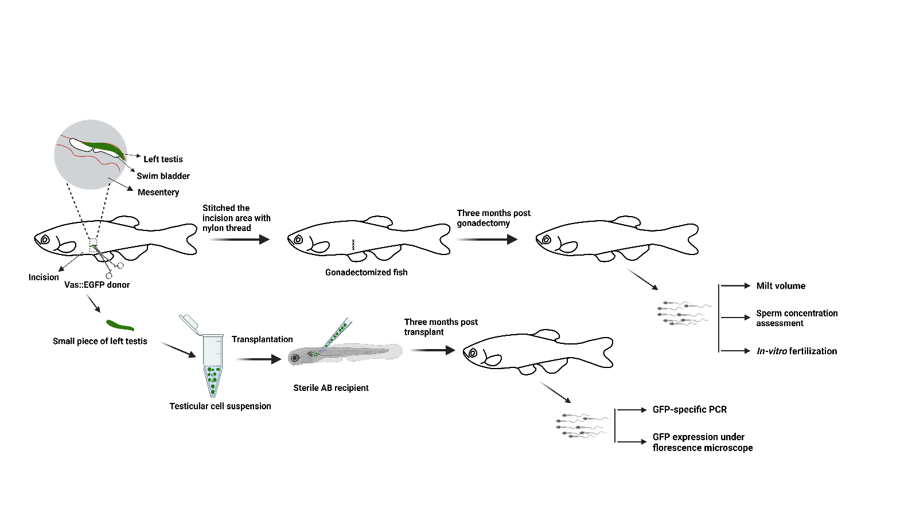
Figure 1. Schematic representation of the study design in zebrafish. This figure is created using Biorender.com.

Methods

Fish husbandry and recipient production
Vas::EGFP zebrafish lines were originally procured from the University of Liege, Belgium, and AB wildtype strains were procured from KIT, Germany. Vas::EGFP zebrafish is the transgenic line where the EGFP reporter gene is under the control of vas promoter and expressed exclusively in germ cells (Krøvel and Olsen, 2002). Zebrafish lines were held in our facility for several generations at 28 °C, photoperiod 14L:10D, and fed with Artemia nauplii and a dry diet. AB line broodstocks were prepared for spawning by separating males and females in a breeding chamber the night before. The following day, barriers were removed, and the mating pairs were allowed to spawn for up to 30 minutes. Embryos were collected immediately after spawning from the breeding chamber and transferred to a clean Petri dish. Primordial germ cell migration was prevented by dead-end antisense morpholino nucleotide (dnd-MO, 5′-GCTGGGCATCCATGTCTCCGACCAT-3 ′(Weidinger et al., 2003). 1M stock of dnd-MO was diluted with 0.2M KCL to a final concentration of 0.1M and injected into the embryos at the 1-2 cell stage through the chorion (Ciruna et al., 2002). The injected embryos were held at 28 °C until hatching with a daily clean water change.

Gonadectomy in zebrafish
One-year-old vas::EGFP zebrafish (n = 10) were anesthetized with 0.05% of tricaine methanesulfonate (MS222). The fish was pat dry gently with a Kimwipe. The incision was intended to be above the cranial end of the ventral fin. Therefore, scales in the area were removed to ease the incision and subsequent sutures. The skin was lifted by forceps, and a small vertical cut in the lateral muscle was made by fine, sharp forceps towards the dorsum. Then, the body cavity was approached by scissors with dull tips to minimize the risk of damaging internal organs or blood vessels. The overall length of the incision was about 3 mm. The male gonads can be easily identified by their milky white colour and visible spermatogenic cysts at high magnification. The testes were gently grabbed by forceps, and its cranial segment was resected while the caudal end was left intact to not damage sperm ducts. The incision was closed using nylon sutures and ultra-fine forceps when both sides of the incision were pierced, and nylon thread was pulled through and fixed by a triple knot. The overall surgery time for each fish was less than five minutes. After surgery, males were placed in well-aerated aquaria with 1% NaCl with subsequent water changes without saline over three days.

Gonadectomy in killifish and reproduction
Partial gonadectomy was performed on 6-week-old males in an identical manner as described above for zebrafish. After the recovery period, breeding tanks for both operated and same-operated males were set up. One male was placed with two females, and eggs were collected on a weekly basis for three consecutive weeks. Developing and dead embryos were counted and expressed as developmental rates.

Transplantation in zebrafish
Testicular tissue was isolated from all the donors (n = 10) and pooled. The pooled tissue was cut into pieces with a sterile scissor and washed with PBS to remove the excess amount of sperm. The testicular fraction was then subjected to enzymatic digestion with 0.1% trypsin (trypsin from porcine pancreas), 0.05% collagenase Type I (collagenase from Clostridium histolyticum), and 0.5% DNAse I (DNAse I from bovine pancreas) in PBS for 50 minutes at 22-23 ℃ on a shaker. Enzymatic digestion was terminated after 50 minutes by adding one volume of L-15 medium (Leibovitz's L-15 Medium) supplemented with 20% foetal bovine serum (FBS). The cell suspension was filtered through a 45 µm pore size filter (CellTrics) and centrifuged at 400g for 10 minutes. The cell pellet was resuspended with L15 and transplanted into the 5dpf AB sterile recipients.

Four males from the same age group were gonadectomized similarly to count the number of spermatogonial cells. Testis fractions were obtained from each male and processed separately for testicular cell isolation, as described above. Isolated cell suspension was diluted at a 1:2 ratio with Trypan blue (Cytiva HyClone™) solution for viable spermatogonial cell counting using a Bürker chamber. Cells were counted two times at an average to ensure the reproducibility of the data.

Reproductive performance assessment in zebrafish gonadectomized males
One-year-old vas::EGFP males (controls, non-gonadectomized males) and females were kept in breeding chambers a night before the spawning. The barriers were removed the following day, and the mating pairs were closely monitored for oviposition. Oviposited females and males were immediately transferred to the lab. First, ten males were anesthetized with 0.05% of MS222. Semen samples were collected separately in the E400 extender at a 1:10 ratio by gentle abdominal pressure, and the semen volume was recorded for each male. Similarly, semen samples from ten gonadectomized donors three months post-gonadectomy (n = 10 biological replicates) were collected in separate vials, and the volumes were recorded. Next, eggs were collected from the ovulating females (n = 10, pooled) by gentle abdominal massage in a clean petri dish. Half the volume of the collected semen from the control males and the gonadectomized donors was used for in vitro fertilization separately for each individual to determine the fertilization rate. The fertilization rate was determined according to the embryo survival rate until the segmentation period. The remaining semen samples were used for sperm concentration assessment using a Bürker chamber for the control males (n = 10 biological replicates) and for the gonadectomized males (n = 10 biological replicates).

Germline chimera assessment in zebrafish
Three months post-transplant, semen samples were collected from the surviving recipients in the E400 extender at a 1:10 ratio by gentle abdominal pressure (Matthews et al., 2018). Collected sperm samples were checked for the presence of EGFP under fluorescence and by EGFP-specific PCR amplification using forward primer 5ʹ- ACGTAAACGGCCACAAGTTC -3ʹ, and reverse 5ʹ- AAGTCGTGCTGCTTCATG -3. The amplification conditions were 94 °C for 5 minutes and 35 cycles of 94 °C for 30 seconds, 58 °C for 30 seconds, and 72 °C for 45 seconds, with a final extension of 72 °C for 5 minutes. One adult recipient was dissected to observe the gonadal development and the GFP expression in the testis.

Histology
After the sperm concentration and fertilization assessment, all gonadectomized donors were sacrificed by overdose of Tricaine. Males were dissected, and the regenerated part of the testis was photographed under a fluorescence microscope. Next, the regenerated part of the left testis was carefully taken and fixed with Bouin's solution for 24 hours, and similarly, the right testis was fixed separately with Bouin’s solution for 24 hours. After fixation, the testis was dehydrated with a series of ethanol solutions followed by infiltration and resin embedding using the JB4 Embedding Kit (Sullivan-Brown et al., 2010). Next, the tissue was cut into 5 µm thick serial sections using a rotary Microtome. The tissue sections were stained with Hematoxylin and Eosin and analyzed under a BX63 Olympus Fluorescence microscope.

Statistical analysis
Data for sperm concentration, milt volume, total sperm count, and fertilization rate were first checked for normal distribution using Shapiro-Wilk and Kolmogorov-Smirnov test. The data with normal distribution were analysed with a t-test, and data that did not pass the normality test were analysed with the Mann-Whitney test.

Results

Partial gonadectomy in zebrafish males does not affect survival and reproductive performance
We monitored the gonadectomized males after non-lethal testis collection for up to three months. All testicular tissue donors (n = 10) survived partial gonadectomy. Next, we aimed to see the reproductive performance of all the donors and compare them with the normal vas::EGFP transgenic males that are non-gonadectomized from the same age group (one-year-old). The donors were reproduced three months post-gonadectomy to check the milt volume, sperm concentration, and fertilization rate. The reproductive outputs of the donors were not significantly different from the normal males (Figure 2A-D). Then, the donors were dissected to see if the left testis was regenerated, and we observed an intact structure of the left testis in all the dissected individuals with a very prominent GFP expression near the dissected part of the left testis (Figure 2J-J', the area is depicted by a yellow rectangle). Histology of the depicted region showed the presence of a lower population of final-stage spermatids compared to the undissected right testis. The regenerated part of the left testis mainly accumulated by spermatogonia type B (early and late) and meiotic spermatocytes, while the right testis was mostly occupied by the spermatids. These results indicate that the newly regenerated part has initiated spermatogenesis and possesses the characteristics of an immature testis.

Table 1. The number of testicular cells in the partially resected zebrafish testis
 | Length of resected segment (in mm) | Number of viable cells/ml
Male 1 | 1.98 | 95.9 × 10⁵
Male 2 | 1.99 | 80.9 × 10⁵
Male 3 | 2.11 | 72.3 × 10⁵
Male 4 | 2.49 | 132.5 × 10⁵

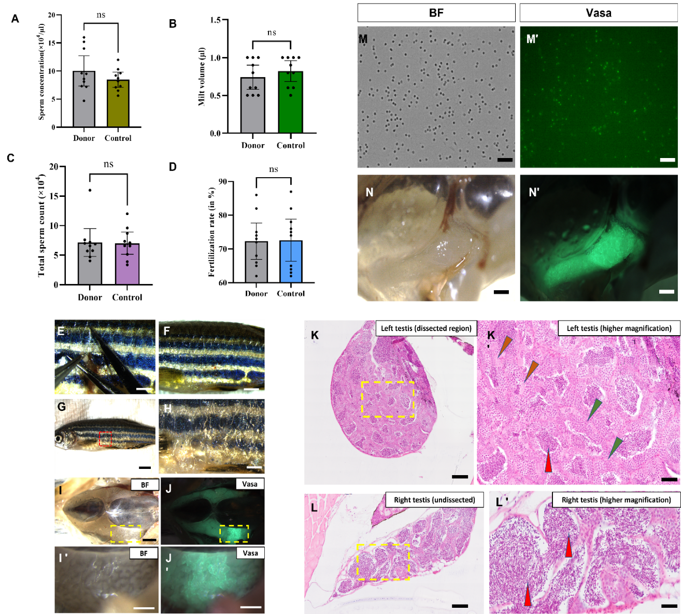

Figure 2. Gonadectomy and germline chimera production in zebrafish.
A-D) Reproductive performance by the donor individuals, sperm concentration, milt volume, total sperm count, and fertilization success, respectively, the data represent the mean with 95% confidence interval, P ˂ 0.05, n = 10. E) A donor during the partial removal of the left testis, F) The incision area is sutured after the partial resection, G-H) Partially gonadectomized donor after three months of surgery, the incision area is healed completely, I-J) Regenerated region of left testis depicted by the yellow rectangle expressing a prominent signal for GFP when compared to other parts of the testis. I'-J') Higher magnification of the depicted area. K-K') The transverse section of the depicted area in the left testis has orange arrowheads indicating spermatogonia, green arrowheads indicating primary spermatocytes, and red arrowheads indicating spermatozoa. L-L') The right testis shows a large population of spermatozoa, indicated by red arrowheads. M) Sperm derived from the adult germline chimera under brightfield, and M') The same milt sample under the FITC filter shows the GFP expression in the spermatozoa. N) Three-month-old dissected adult germline chimera under brightfield, N') Testis with GFP expression under FITC filter. BF- brightfield. Scale bars, E, F, G, H, I and J = 1mm, I', J', K and L = 200 µm, K' and L' = 100 µm, M and M ' = 20 µm, N and N' = 1 mm.

Reproduction outputs in killifish

We observed no mortality after partial gonadectomy in the killifish males. Fourteen days post-gonadectomy, the gonadectomized males were spawned for three consecutive weeks to record their reproductive performance. The developmental rate of the embryos was comparable to that of the control males (Figure 3), suggesting that the partial gonadectomy did not compromise sperm production.

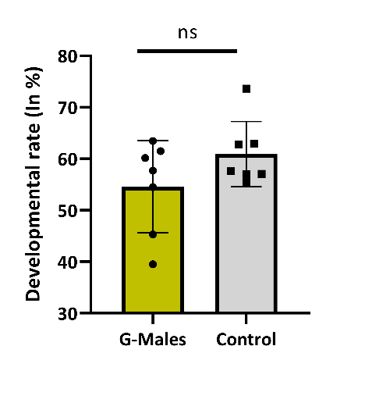
Figure 3. Killifish reproduction post-partial gonadectomy.
Killifish males (n = 7 biological replicates) fourteen days later partial gonadectomy. Each male was paired with two females and spawned. Spawning was repeated three times to get the average developmental rate of the eggs laid for each gonadectomized male. The data represent the mean with SD, P ˂ 0.05, n = 7. G-Males — Gonadectomized males, ns — Not Significant.

Germline chimera in zebrafish
The survived transplanted recipients (n = 63) were checked for the presence of vas::EGFP cells after ten days of transplantation, and 16% (n = 10) of the recipients contained GFP-positive cells. Three months post-transplantation, the recipients were stripped to collect the semen samples, and only four recipients produced the milt containing donor-derived sperm confirmed by GFP-specific PCR amplification (data not shown) and the expression of GFP under a fluorescence microscope (Figure 2M- M'). One of the confirmed germline chimeras was dissected to see the testis development and vas::EGFP expression under a fluorescence microscope. We observed unilaterally developed testis with prominent GFP expression (Figure 2N - N')

Discussion
Here, we have reported the regeneration of the testis after partial gonadectomy in two small-bodied species, zebrafish and turquoise killifish, with zero mortality. We have developed a new approach to obtain germ stem cells from the donor without sacrificing the fish by performing a non-lethal partial gonadectomy in zebrafish. Although zebrafish is a small-bodied fish model, we achieved 100% survival in operated tissue donors. The isolated cell suspension from the donors was enough to transplant 63 recipients. We observed that the dissected part of the left testis was capable of complete regeneration in zebrafish. Interestingly, we could easily distinguish the regenerated part of the gonad by visual inspection when strong EGFP expression was confirmed, suggesting a large proportion of early-stage germ cells. Subsequently, histology of the regenerated region shows a low population of spermatozoa.
Partial gonadectomy did not compromise the milt volume or the total sperm count in the gonadectomized individuals compared to the non-gonadectomized controls of the same age. This study shows that partial gonadectomy in zebrafish could not alter the quality or quantity of sperm production. The success of germline chimera production in fish is unpredictable, with a risk of losing the donor species in each transplantation. This approach offers a unique opportunity to keep the donor alive. Moreover, the germ stem cells have the ability to regenerate again in the partially gonadectomized donors, which provides another chance to prepare the donor cells if the transplantation fails to work in the first trial. Gonadectomy has previously been reported in European catfish Silurus glanis to isolate gonad In vivo in order to obtain milt for in vitro fertilization without urine contamination (Pronina and Petrushin, 2019) and to study the sex steroid in Japanese medaka Oryzias latipes (Royan et al., 2020). Since the surrogate production approach has immense potential for gene banking of endangered species like sturgeon (Pšenička, 2014) and commercially valuable species, common carp (Franěk et al., 2021), the combination of partial gonadectomy and transplantation may provide new insight for the research community aims at germline chimera generation. Future studies may assess the potential of gonad regeneration in larger species that have longer maturation periods, like sturgeon, salmonids, and common carp.

Conclusion
Partial gonadectomy in zebrafish did not compromise the reproductive performances and provided a suitable alternative for spermatogonial cell isolation for germline chimera production without sacrificing the donors. Gonadectomy in killifish males did not affect fertility, and the developmental rate of the laid eggs was comparable to that of non-gonadectomized males.

Declarations
Funding
The work was supported by the Ministry of Education, Youth and Sports of the Czech Republic - project Biodiversity (CZ.02.1.01/0.0/0.0/16_025/0007370), and the Czech Science Foundation (grant number 22-31141J). This project has received funding from the European Union's Horizon 2020 Research and Innovation Programme under grant agreement No 871108 (AQUAEXCEL3.0). This output reflects only the author's view, and the European Union cannot be held responsible for any use that may be made of the information contained therein.

Ethics approval and consent to participate
The study was conducted at the Faculty of Fisheries and Protection of Waters (FFPW), the University of South Bohemia in Ceske Budejovice, Vodnany, Czech Republic. The facility has the competence to perform experiments on animals (Act no. 246/1992 Coll., ref. number 16OZ19179/2016–17214). The Institutional Animal Care and Use Committee of the FFPW approved the methodological protocol of the current study according to the law on the protection of animals against cruelty (reference number: MSMT-6406/2019–2). The study did not involve endangered or protected species. Authors of the study (RF and MP) own the Certificate of professional competence for designing experiments and experimental projects under Section 15d (3) of Act no. 246/1992 Coll. on the Protection of Animals Against Cruelty.
Acknowledgment
Not applicable

Consent for publication
Not applicable

Competing interests
The authors declare that they have no competing interests.

Authors’ contributions
RN performed the experiments and data analysis and wrote the manuscript. RF conceptualized and supervised the study and performed some experiments. MP helped with manuscript review and editing. All the authors read and approved the manuscript. All the authors read and approved the manuscript.

References

Ciruna, B., Weidinger, G., Knaut, H., Thisse, B., Thisse, C., Raz, E., Schier, A.F., 2002. Production of maternal-zygotic mutant zebrafish by germ-line replacement. Proc. Natl. Acad. Sci. U. S. A. 99, 14919–14924.
Franěk, R., Tichopád, T., Fučíková, M., Steinbach, C., Pšenička, M., 2019. Production and use of triploid zebrafish for surrogate reproduction. Theriogenology. 140, 33–43.
Franěk, R., Kašpar, V., Shah, M.A., Gela, D., Pšenička, M., 2021. Production of common carp donor-derived offspring from goldfish surrogate broodstock. Aquaculture. 534.
Hamasaki, M., Takeuchi, Y., Yazawa, R., Yoshikawa, S., Kadomura, K., Yamada, T., Miyaki, K., Kikuchi, K., Yoshizaki, G., 2017. Production of tiger puffer Takifugu rubripes offspring from triploid grass puffer Takifugu niphobles parents. Mar. Biotechnol. 19, 579–591.
Hattori, R.S., Yoshinaga, T.T., Katayama, N., Hattori-Ihara, S., Tsukamoto, R.Y., Takahashi, N.S., Tabata, Y.A., 2019. Surrogate production of Salmo salar oocytes and sperm in triploid Oncorhynchus mykiss by germ cell transplantation technology. Aquaculture. 506, 238–245.
Ichida, K., Hayashi, M., Miwa, M., Kitada, R., Takahashi, M., Fujihara, R., Boonanuntanasarn, S., Yoshizaki, G., 2019. Enrichment of transplantable germ cells in salmonids using a novel monoclonal antibody by magnetic-activated cell sorting. Mol. Reprod. Dev. 86, 1810–1821.
Iwasaki-Takahashi, Y., Shikina, S., Watanabe, M., Banba, A., Yagisawa, M., Takahashi, K., Fujihara, R., Okabe, T., Valdez, D.M., Yamauchi, A., Yoshizaki, G., 2020. Production of functional eggs and sperm from in vitro-expanded type A spermatogonia in rainbow trout. Commun. Biol. 31 (3), 1–11.
Krøvel, A.V., Olsen, L.C., 2002. Expression of a vas::EGFP transgene in primordial germ cells of the zebrafish. Mech. Dev. 116, 141–150.
Lee, S., Iwasaki, Y., Shikina, S., Yoshizaki, G., 2013. Generation of functional eggs and sperm from cryopreserved whole testes. Proc. Natl. Acad. Sci. U. S. A. 110, 1640–1645.
Lee, S., Seki, S., Katayama, N., Yoshizaki, G., 2015. Production of viable trout offspring derived from frozen whole fish. Sci. Rep. 5, 1–12
Marinović, Z., Li, Q., Lujić, J., Iwasaki, Y., Csenki, Z., Urbányi, B., Yoshizaki, G., Horváth, Á., 2019. Preservation of zebrafish genetic resources through testis cryopreservation and spermatogonia transplantation. Sci. Rep. 9.
Matthews, J.L., Murphy, J.M., Carmichael, C., Yang, H., Tiersch, T., Westerfield, M., Varga, Z.M., 2018. Changes to extender, cryoprotective medium, and in vitro fertilization improve zebrafish sperm cryopreservation. Zebrafish. 15, 279.
Morita, T., Morishima, K., Miwa, M., Kumakura, N., Kudo, S., Ichida, K., Mitsuboshi, T., Takeuchi, Y., Yoshizaki, G., 2015. Functional sperm of the Yellowtail (Seriola quinqueradiata) were produced in the small-bodied surrogate, Jack Mackerel (Trachurus japonicus). Mar. Biotechnol. 17, 644–654.
Nóbrega, R.H., Greebe, C.D., van de Kant, H., Bogerd, J., de França, L.R., Schulz, R.W., 2010. Spermatogonial stem cell niche and spermatogonial stem cell transplantation in zebrafish. PLoS One 5, 1–16.
Octavera, A., Yoshizaki, G., 2019. Production of donor-derived offspring by allogeneic transplantation of spermatogonia in Chinese rosy bitterling. Biol. Reprod. 100, 1108–1117.
Okutsu, T., Suzuki, K., Takeuchi, Y., Takeuchi, T., Yoshizaki, G., 2006a. Testicular germ cells can colonize sexually undifferentiated embryonic gonad and produce functional eggs in fish. Proc. Natl. Acad. Sci. U. S. A. 103, 2725–2729.
Pronina G. I., Petrushin A. B., 2019 Techniques for in vivo extraction of gonads of male European catfish (Silurus glanis) for artificial reproduction. AACL Bioflux. 12(4):1316-1322.
Pšenička, M., Saito, T., Linhartová, Z., Gazo, I., 2015. Isolation and transplantation of sturgeon early-stage germ cells. Theriogenology. 83, 1085–1092.
Pšenička, M., Saito, T., Rodina, M., Dzyuba, B., 2016. Cryopreservation of early stage Siberian sturgeon Acipenser baerii germ cells, comparison of whole tissue and dissociated cells. Cryobiology. 72, 119–122.
Ren, Y., Sun, Z., Wang, Y., Yu, Q., Wang, G., He, Z., Liu, Y., Jiang, X., Kang, X., Hou, J., 2021. Production of donor-derived offsprings by allogeneic transplantation of oogonia in the adult Japanese flounder (Paralichthys olivaceus). Aquaculture. 543, 736977.
Royan, M.R., Kanda, S., Kayo, D., Song, W., Ge, W., Weltzien, F.A., Fontaine, R., 2020. Gonadectomy and blood sampling procedures in the small size teleost model Japanese medaka (Oryzias latipes). J. Vis. Exp. 166.
Sullivan-Brown J, Bisher ME, Burdine RD., 2011. Embedding, serial sectioning, and staining of zebrafish embryos using JB-4 resin. Nat Protoc. 6(1):46-55.
Weidinger, G., Stebler, J., Slanchev, K., Dumstrei, K., Wise, C., Lovell-Badge, R., Thisse, C., Thisse, B., Raz, E., 2003. Dead end, a novel vertebrate germ plasm component is required for zebrafish primordial germ cell migration and survival. Curr. Biol. 13, 1429–1434.
Ye, H., Li, C.J., Yue, H.M., Du, H., Yang, X.G., Yoshino, T., Hayashida, T., Takeuchi, Y., Wei, Q.W., 2017. Establishment of intraperitoneal germ cell transplantation for critically endangered Chinese sturgeon Acipenser sinensis. Theriogenology. 94, 37–47.
Yoshikawa, H., Takeuchi, Y., Ino, Y., Wang, J., Iwata, G., Kabeya, N., Yazawa, R., Yoshizaki, G., 2017. Efficient production of donor-derived gametes from triploid recipients following intra-peritoneal germ cell transplantation into a marine teleost, Nibe croaker (Nibea mitsukurii). Aquaculture. 478, 35–47.
Zhao, G.Q., Garbers, D.L., 2002. Male Germ Cell Specification and Differentiation. Dev. Cell. 2, 537–547.

Chapter 5

General discussion
English summary
Czech summary
Acknowledgements
List of publications
Training and supervision plan during study
Curriculum vitae

- General Discussion
Xenogenic transplantation using commonly used model species, zebrafish were transplanted into a large-bodied recipient giant danio to produce a suitable surrogate that can efficiently produce zebrafish gametes in a significantly higher amount than that of the donor. The systematic procedure of producing sterile giant danio was developed to ablate the endogenous germ cells completely. This study (Chapter 2) revealed the genetic compatibility of giant danio gonadal somatic cells to accommodate and nourish the germ cells from a species of different genera. Chapter 3 verified and strengthened our understanding, for the first time, of the epigenetic changes acquired by the donor germ cells and their possible inheritance to future generations. Since many studies now deal with germ cell transplantation in fish to assess or produce germline chimera, it is crucial to consider the donor's safety. Chapter 4 successfully developed an approach to harvest the testicular cells for transplantation in zebrafish with no mortality in the donor. This study (chapter 4) used smaller species (zebrafish and killifish) to conduct partial gonadectomy in order to show that big-body-sized species will be much more suitable for this experiment and can survive the procedure.

  - Germ cell compatibility and development in the xenogenic recipient
The success of germline chimera production between genetically distant species can be challenging for well-known reasons, such as the failure of transplanted germ cell coalescence with the supporting gonadal somatic cells of the recipient. The interaction seems simple when working with closely related species belonging to the same genera. The difficulty may arise as the genetic distance goes farther. Another factor is the degree of sterility in the host, as some methods, like triploidization and interspecific hybridization, do not entirely remove the endogenous germ cells. Germ cell development and proliferation are supported by the gonadal niche created by the supporting cells, Sertoli cells, and extracellular matrix (Schulz et al., 2010). The presence of even fewer endogenous germ cells may induce competition to retain in the supporting microenvironment, leading to the rejection of foreign germ cell incorporation and development. This section deals with various factors contributing to the success and failure of germ cell development in the xenogenic recipient post-transplantation.

Genetic compatibility –
The rate of transplantation efficiency is comparatively higher at the species level than at the genus and family level. The incorporation of transplanted germ cells between the same species leads to low rejection because of their strong genetic compatibility. However, few studies have reported successful germline chimera production in recipients from different orders (Silva et al., 2016), families (Saito et al., 2008), subfamilies (Zhang et al., 2022) and genera (Morita et al., 2015; Hamasaki et al., 2017; Franěk et al., 2021; Nayak et al., 2023). There are studies that report no donor-derived production after xenogenic transplantation (Bar et al., 2016; Yazawa et al., 2010). The successful studies indicate that the germ-soma interaction may be conserved in some teleost, potentially supporting the proliferation of foreign germ cells. However, the efficiency or the number of germline chimera produced is relatively low, as observed in Chapter 2 with giant danio recipients. The interaction required for xenogenic germ-soma coalescence has never been explored experimentally and remains to be unveiled. In addition, the germ-soma interaction and their development is sometimes specific to the species. Gametogenesis is a highly coordinated process and cellular communication between developing germ cells and supporting somatic cells. The gap junction transmembrane protein connexins (Cxs) are reported to play a crucial role in cell-cell communication during every stage of gametogenesis in the teleost (De Montgolfier et al., 2007). Notably, fish testis expresses a variety of Cxs (Cheng et al., 2004; De Montgolfier et al., 2007) that may be species-specific and facilitate germ cell development. Considering this, it can be assumed that cellular receptors and molecular factors are required to respond and interact with the transplanted germ cells, failing which leads to their rejection. To date, the only means to check the germ cell compatibility between the genetically distant species is to perform the germ cell transplantation assay.

Stemness of germ cell –
The stemness of a germ cell can be described as the most undifferentiated state of its lineage. As the reports suggest, the germ cell with stemness can only colonize the recipient gonad post-transplantation (Ichida et al., 2019). Embryonic germ stem cells, PGCs, are highly pluripotent and can populate the host gonad from different genera and families (Ciruna et al., 2002; Saito et al., 2008, 2010). Xenogeneic germline chimera production is assumed to be highly efficient with PGC transplantation. However, this method is rarely successful due to the high mortality of host embryos post-transplantation and the skill-sensitiveness that requires delicate micromanipulation. Testicular cell suspensions isolated from the adults contain all stages of spermatogonia, such as proliferating/self-renewing, differentiating, and most differentiated. Reportedly, only SPG-A possesses the ability to incorporate into the empty gonad (Iwasaki-Takahashi et al., 2020). This phenomenon is well described in Chapter 2 with supporting results, as the total testicular suspension from zebrafish failed to colonize the giant danio gonad, but the cell enrichment with density gradient centrifugation (a method to selectively isolate cell population with lower density from the total cell suspension) potentially helped to generate germline chimera. However, the total testicular cell suspension was able to successfully colonize the recipient gonad in zebrafish intraspecific transplantation (transplantation was performed between different strains of zebrafish) (Franěk et al., 2019b, 2022). These reports clearly indicate that the stemness of germ cells potentially contributes to the efficiency of xenogenic transplantation. There are several techniques have developed for SPG-A enrichment, such as In vitro expansion of SPG-A through cell culture (Iwasaki-Takahashi et al., 2020), cell sorting using monoclonal antibodies (Ichida et al., 2019), and flow cytometry enrichment base on light scattering properties (Kise et al., 2012). Furthermore, germ cell stemness properties do not guarantee transplantation success between all distant species where the genetic compatibility factors are at play, but it is one of the essential factors to consider during germ cell isolation in order to improve efficiency.

Host sterility –
The degree of host sterility substantially affects the incorporation of donor germ cells in xenogenic transplantation. The farther the phylogenetic distance between donor and recipient, the stronger the possibility of rejection post-transplantation. Complete removal of germ cell precursors during embryonic development using gene knockout or knockdown techniques is favorable for genetically distant recipients. Other recipients, such as triploids and interspecific hybrids, may outcompete the transplanted germ cells and lead to no or very low colonization rate of the donor germ cell. A study by Franěk et al. reported that the dnd knockdown recipients are more favorable than those produced by other methods (Franěk et al., 2022), as they offer empty niches that can accommodate only exogenous germ cells. The study performed in Chapter 3 reported that interspecific hybrid surrogates produced recipient-derived spermatozoa, which significantly decreased the fertilization rate of the donor-derived gametes, indicating the level of sterility is a crucial factor. Although it is hard to assess or assume the exogenous germ cell incorporation rate considering only the degree of sterility, a constant factor, many other factors mentioned above can be a potential reason for transplantation failure.

  - Germ-soma interaction post-transplantation and their functional consequences
The interaction of introduced germ cells with the gonadal microenvironment of the recipient poses several questions on their practical application or reliability on surrogate broodstock propagation. Several successful studies have been reported for donor-derived gamete production via germline chimera, as apparent by several published studies. However, information on the journey of exogenous germ cells post-transplantation and their development has never been acquired. The study reported in Chapter 3 has provided new insight into scenarios underlying germ-soma interaction in the recipient gonad at the individual and species levels with possible molecular consequences. As shown in the supported literature (chapter 3), the morphological variations were reported in a few studies in donor-derived gametes and progeny (Saito et al., 2008; Franěk et al., 2021) that draw our attention to the molecular changes underlying these phenotypes and their possible causes. Unlike genetic mutations, epigenetic modifications are more likely to occur due to environmental stress. It is known that epigenetic marks play a critical role in gene regulation and thereby control cellular functions. The surrogate production approach needs immediate attention regarding epigenetic modifications as they involve many systematic procedures where the donor germ cells are subjected to physical stressors, beginning from their isolation to gametogenesis in the recipient gonad. This thesis's primary goal was to address the compatibility of donor germ cells with recipient gonadal somatic cells, which also involves deciphering their interactions in a new microenvironment in different surrogate types. The DNA methylome comparison between the interspecific (xenogenic) and intraspecific (allogenic) chimera revealed many alterations, described thoroughly in Chapter 3. However, the observed changes in DNA methylation could not induce any phenotypical alterations in the F1 offspring. The discussion remains on whether there is a threshold of methylation density to give a phenotypical response that needs to be validated in future studies. In addition, this study involved recipients from the same species and the hybrids, where one parent is the same as the donor species. The effect of the recipient’s gonadal microenvironment may not be drastic on the donor germ cells and their development. Moreover, the author would like to point out the limitation of the study reported in Chapter 3 on phenotypical analysis of the F1 progeny. Although the progenies did not show any severe malformations for pcdh1g promoter hypermethylation, a more comprehensive analysis of the micro phenotypical analysis on the F1 progenies derived from the intraspecific surrogate would have been beneficial to claim these findings. The lack of additional trait variability observation was because of the unavailability of living biological material due to a long gap between obtaining the methylome data and investigating phenotypical and behavioral analysis. However, our future study will cover the lack of in-depth phenotypical investigation on the donor-derived progeny.

Several reported studies where the recipients are from different genera (like in Chapter 2, (Nayak et al., 2023)) and families (Saito et al., 2008) will be interesting to dissect through their epigenetic remodelling. Knowing the DNA methylation arrangement before and after fertilization is essential to understand the epigenetic alterations in surrogate production. In zebrafish, the paternal methylation pattern is retained in the offspring post-fertilization. In contrast, the maternal pattern is discarded (Jiang et al., 2013), and they do not undergo epigenetic reprogramming like mammals (Skvortsova et al., 2019). On the contrary, another model species, medaka, quite resembles DNA methylation reprogramming in mammalian embryogenesis, where the embryo undergoes epigenetic reprogramming and discard almost all paternal epigenetic marks (Wang and Bhandari, 2020). Unlike zebrafish, species like medaka are presumed to be less susceptible to carrying parental epigenetic marks post-fertilization as they undergo demethylation except for a few genes. This is why this study chose zebrafish to analyse the epimutation after surrogate production. This scenario can differ among species, requiring thorough phenotypic analysis in the donor-derived offspring. Also, the morphological characteristics of the donor-derived gametes must be compared with those of the donor before studying their epigenome. The most important finding from the studies carried out in Chapter 3 is that not all gene regulations are methylation-dependent. Alternatively, they may require a threshold of methylation density to induce any phenotypical changes in the progeny.

The changes resulting from the foreign germ-soma interaction may induce some aberrant alternation in the donor-derived gametes. However, whether their persistence is transient or permanent over generations is an essential question for future studies. Dimethyl sulfoxide (DMSO) is often used as a cryoprotectant for long-term germ cell preservation (Pšenička et al., 2016; Franěk et al., 2019a; Marinović et al., 2019). Notably, it can change cell fate decisions by inducing DNA methylation (Iwatani et al., 2006). Elucidating the molecular consequences of cryopreserved germ cell transplantation in the produced gametes and the offspring is the next stage of research to check their reliability. The observed results from this comparative study interpret many possible explanations: 1) Firstly, the transplanted cells undergo a natural selection where the damaged cells or cells with aberrant epigenetic makeup may not undergo proliferation and differentiation in the recipient's gonad, and the healthier cells proceed further, 2) or the opposite scenario could be that the cell with a newly gained epigenetic makeup caused by the recipient's gonadal microenvironment that survives only undergoes differentiation, and others die. In both cases, the consequences are worth knowing in order to understand the nature of transplanted germ cell and recipient gonadal somatic cell interactions.

  - Easing the germ cell isolation from the donors
It is highly unpredictable to expect the success of germline chimera production in the case of xenogenic germ cell transplantation. Surrogate production is a complex and time-consuming technique, and the success often depends on many factors besides the genetic relationship and host sterility. These failures lead to the repetition of the whole procedure that involves harvesting the fresh germ cells from the donor, involving sacrifice. This thesis developed a partial gonadectomy approach to isolate the donor testis by resection and suturing them back, as described in Chapter 4. In our study, partial gonadectomy proved non-lethal for the smallest species, zebrafish and killifish. This technique potentially offered an alternative approach to killing donors during germ cell isolation. The developed approach may substantially help some valuable species, like sturgeon, that take years to mature sexually and require intense care during rearing. Transgenic lines and the lines developed with genome editing technologies are valuable to lose. The gonadectomy in zebrafish and killifish did not compromise their reproductive output because the resected part of the testis was regenerated. This again provides another opportunity to use the same donor for germ cell isolation for surrogate production. In addition, this technique did not report any mortality in the gonadectomized individuals for both zebrafish and killifish.

  - Conclusions and future directions in germ cell transplantation
Germ cell transplantation technologies can potentially help genetic improvement in aquaculture, as proven by several successful studies mentioned in the above chapters. New tools and techniques are emerging with time, adding more potential to the surrogate broodstock technologies to work with genetically distant species. Speeding up the maturation period for species with long reproductive cycles with a surrogate with a shorter sexual maturation time may expedite the progeny production (Hattori et al., 2019). Similarly, the species threatened by diseases in their natural habitat and challenging to rear in captivity can be conserved using their germ cell transplantation in a suitable host. Although the success of xenotransplantation is low and the failure is often noticed, it tells us that immune compatibility is low when other factors are promising. Future studies must focus on the immunosystem profiling of the larvae or study the molecular factors involved in rejecting the gonial cell coalescence with somatic cells in distant species. Suppressing these factors by transient gene silencing during the window of germ cell incorporation until their complete occupancy in the recipient gonad may ease xenogenic transplantation. A thorough investigation of interactions between the receptor and ligand of germ cells and recipient gonadal somatic cells may provide insight into the failures. The studies performed in this thesis suggest that xenogenic transplantation from a smaller species into a bigger surrogate parent can efficiently solve the issue of low gamete production. The biotechnologies involving germ cell transplantation have an impact on the donor epigenome in the intraspecific (different strains of the same species) and interspecific germline chimera production (into the interspecific hybrids) that indicates that divergent species may have drastic changes on the donor-derived gametes and may keep this epigenetic memory in the future generations.

The specific conclusions that are drawn from the studies this thesis reported are the following:
- Zebrafish spermatogonial cells show compatibility with the recipient giant danio from a different genus and can be successfully used as a surrogate to produce significantly higher amounts of sperm (Chapter 2).
- Giant danio follows a sex-determination system similar to zebrafish, developing into a mono-sex male population after germ cell depletion (Chapter 2).
- Donor-derived gametes from inter- and intraspecific surrogates present a globally hypermethylated genome compared to the donors. The observed hypermethylation showed no functional/phenotypical changes in the F1 progenies (Chapter 3).
- Protocadherin gamma promoters are found to be hypermethylated in donor-derived sperm and progeny from the intraspecific surrogate; however, the gene expression level remains unchanged (Chapter 3).
- Promoter hypermethylation in the MAPK/p53 pathway genes affects the removal of meiotic-arrested germ cells in the interspecific hybrid surrogate (Chapter 3).
- Partial gonadectomy is the alternative approach of germ cell harvesting from the donor without killing them and compromising their reproductive performance (Chapter 4).
This thesis has addressed the critical points in surrogate production technologies that provide new directions for future xenogenic germ cell transplantation studies. The successful gamete production enhancement using xenogenic transplantation allows the testing of other species with low fecundity. All the performed studies included in this Ph.D. dissertation are new and first reported in this field, be it boosting gamete production, investigating donor-derived gametes epigenome, or germ cell harvesting with a non-lethal protocol. Epigenetic alteration influenced by germ cell transplantation is the first and novel in this field to be reported using zebrafish. The results obtained from this experiment open many questions on the studies performed in the past and possibly be reported in the future. Surrogate production between genetically distant species needs more attention and careful investigation to ensure that the techniques used do not disturb the normal cellular and molecular functions of the donor species. New studies will elucidate the perturbed epigenetic marks and their consequences using divergent species and the donor-derived gametes produced with cryopreserved germ stem cells. In addition, the cultured gonial cells and PGCs are some important candidates for possible epigenetic remodelling due to long-term culture using medium and growth factors. As this study described in Chapter 3 is the beginning of epigenetic explorations, the subsequent investigations will include verifying every technique involved in surrogate production technologies to know their practical reliability in research and commercial aquaculture.

Reference

Bar, I., Smith, A., Bubner, E., Yoshizaki, G., Takeuchi, Y., Yazawa, R., Chen, B.N., Cummins, S., Elizur, A., 2016. Assessment of yellowtail kingfish (Seriola lalandi) as a surrogate host for the production of southern bluefin tuna (Thunnus maccoyii) seed via spermatogonial germ cell transplantation. Reprod. Fertil. Dev. 28, 2051–2064.
Cheng, S., Shakespeare, T., Mui, R., White, T.W., Valdimarsson, G., 2004. Connexin 48.5 is required for normal cardiovascular function and lens development in zebrafish embryos. J. Biol. Chem. 279, 36993–37003.
Ciruna, B., Weidinger, G., Knaut, H., Thisse, B., Thisse, C., Raz, E., Schier, A.F., 2002. Production of maternal-zygotic mutant zebrafish by germ-line replacement. Proc. Natl. Acad. Sci. U. S. A. 99, 14919–14924.
De Montgolfier, B., Dufresne, J., Letourneau, M., Nagler, J.J., Fournier, A., Audet, C., Cyr, D.G., 2007. The expression of multiple connexins throughout spermatogenesis in the rainbow trout testis suggests a role for complex intercellular communication. Biol. Reprod. 76, 2–8.
Franěk, R., Cheng, Y., Fučíková, M., Kašpar, V., Xie, X., Shah, M.A., Linhart, O., Šauman, I., Pšenička, M., 2022. Who is the best surrogate for germ stem cell transplantation in fish? Aquaculture. 549, 737759.
Franěk, R., Kašpar, V., Shah, M.A., Gela, D., Pšenička, M., 2021. Production of common carp donor-derived offspring from goldfish surrogate broodstock. Aquaculture. 534.
Franěk, R., Marinović, Z., Lujić, J., Urbányi, B., Fučíková, M., Kašpar, V., Pšenička, M., Horváth, Á., 2019a. Cryopreservation and transplantation of common carp spermatogonia. PLoS One. 14, 1–17.
Franěk, R., Tichopád, T., Fučíková, M., Steinbach, C., Pšenička, M., 2019b. Production and use of triploid zebrafish for surrogate reproduction. Theriogenology. 140, 33–43.
Hamasaki, M., Takeuchi, Y., Yazawa, R., Yoshikawa, S., Kadomura, K., Yamada, T., Miyaki, K., Kikuchi, K., Yoshizaki, G., 2017. Production of Tiger Puffer Takifugu rubripes Offspring from Triploid Grass Puffer Takifugu niphobles Parents. Mar. Biotechnol. 19, 579–591.
Hattori, R.S., Yoshinaga, T.T., Katayama, N., Hattori-Ihara, S., Tsukamoto, R.Y., Takahashi, N.S., Tabata, Y.A., 2019. Surrogate production of Salmo salar oocytes and sperm in triploid Oncorhynchus mykiss by germ cell transplantation technology. Aquaculture. 506, 238–245.
Ichida, K., Hayashi, M., Miwa, M., Kitada, R., Takahashi, M., Fujihara, R., Boonanuntanasarn, S., Yoshizaki, G., 2019. Enrichment of transplantable germ cells in salmonids using a novel monoclonal antibody by magnetic-activated cell sorting. Mol. Reprod. Dev. 86, 1810–1821.
Iwasaki-Takahashi, Y., Shikina, S., Watanabe, M., Banba, A., Yagisawa, M., Takahashi, K., Fujihara, R., Okabe, T., Valdez, D.M., Yamauchi, A., Yoshizaki, G., 2020. Production of functional eggs and sperm from in vitro-expanded type A spermatogonia in rainbow trout. Commun. Biol. 3, 308.
Iwatani, M., Ikegami, K., Kremenska, Y., Hattori, N., Tanaka, S., Yagi, S., Shiota, K., 2006. dimethyl sulfoxide has an impact on epigenetic profile in mouse embryoid body. Stem Cells. 24, 2549–2556.
Jiang, L., Zhang, Jing, Wang, J.J., Wang, L., Zhang, L., Li, G., Yang, X., Ma, X., Sun, X., Cai, J., Zhang, Jun, Huang, X., Yu, M., Wang, X., Liu, F., Wu, C.I., He, C., Zhang, B., Ci, W., Liu, J., 2013. Sperm, but not oocyte, DNA methylome is inherited by zebrafish early embryos. Cell. 153, 773–784.
Kise, K., Yoshikawa, H., Sato, M., Tashiro, M., Yazawa, R., Nagasaka, Y., Takeuchi, Y., Yoshizaki, G., 2012. Flow-cytometric isolation and enrichment of teleost type a spermatogonia based on light-scattering properties. Biol. Reprod. 86.
Marinović, Z., Li, Q., Lujić, J., Iwasaki, Y., Csenki, Z., Urbányi, B., Yoshizaki, G., Horváth, Á., 2019. Preservation of zebrafish genetic resources through testis cryopreservation and spermatogonia transplantation. Sci. Rep. 9.
Morita, T., Morishima, K., Miwa, M., Kumakura, N., Kudo, S., Ichida, K., Mitsuboshi, T., Takeuchi, Y., Yoshizaki, G., 2015. Functional sperm of the yellowtail (Seriola quinqueradiata) were produced in the small-bodied surrogate, Jack Mackerel (Trachurus japonicus). Mar. Biotechnol. 17, 644–654.
Nayak, R., Franěk, R., Šindelka, R., Pšenička, M., 2023. Enhancement of zebrafish sperm production via a large body-sized surrogate with germ cell transplantation. Commun. Biol. 6, 412.
Pšenička, M., Saito, T., Rodina, M., Dzyuba, B., 2016. Cryopreservation of early stage siberian sturgeon Acipenser baerii germ cells, comparison of whole tissue and dissociated cells. Cryobiology. 72, 119–122.
Saito, T., Goto-Kazeto, R., Arai, K., Yamaha, E., 2008. Xenogenesis in teleost fish through generation of germ-line chimeras by single primordial germ cell transplantation. Biol. Reprod. 78, 159–166.
Saito, T., Goto-Kazeto, R., Fujimoto, T., Kawakami, Y., Arai, K., Yamaha, E., 2010. Inter-species transplantation and migration of primordial germ cells in cyprinid fish. Int. J. Dev. Biol. 54, 1481–1486.
Schulz, R.W., de França, L.R., Lareyre, J.J., LeGac, F., Chiarini-Garcia, H., Nobrega, R.H., Miura, T., 2010. Spermatogenesis in fish. Gen. Comp. Endocrinol. 165, 390–411.
Silva, M.A., Costa, G.M.J., Lacerda, S.M.S.N., Brandão-Dias, P.F.P., Kalapothakis, E., Silva Júnior, A.F., Alvarenga, E.R., França, L.R., 2016. Successful xenogeneic germ cell transplantation from Jundia catfish (Rhamdia quelen) into adult Nile tilapia (Oreochromis niloticus) testes. Gen. Comp. Endocrinol. 230–231, 48–56.
Skvortsova, K., Tarbashevich, K., Stehling, M., Lister, R., Irimia, M., Raz, E., Bogdanovic, O., 2019. Retention of paternal DNA methylome in the developing zebrafish germline. Nat. Commun. 10, 3054.
Wang, X., Bhandari, R.K., 2020. The dynamics of DNA methylation during epigenetic reprogramming of primordial germ cells in medaka (Oryzias latipes). Epigenetics. 15, 483–498.
Yazawa, R., Takeuchi, Y., Higuchi, K., Yatabe, T., Kabeya, N., Yoshizaki, G., 2010. Chub mackerel gonads support colonization, survival, and proliferation of intraperitoneally transplanted xenogenic germ cells. Biol. Reprod. 82, 896–904.
Zhang, F., Hao, Y., Li, X., Li, Y., Ye, D., Zhang, R., Wang, X., He, M., Wang, H., Zhu, Z., Sun, Y., 2022. Surrogate production of genome-edited sperm from a different subfamily by spermatogonial stem cell transplantation. Sci. China Life Sci. 65, 969–987.

English Summary
Study on the compatibility of germ cells after transplantation into a recipient

Rigolin Nayak
Surrogate production by germline stem cell transplantation is new-age biotechnology to improve aquaculture and basic research pertaining to reproductive biology in fishes. Germ stem cells harvested from the donor at the embryonic or adult stage are transplanted into genetically compatible sterile recipients. The transplanted germ cells are less likely to be rejected by the recipient when the genetic relationship is at the species level. However, the germline chimera production decreases in the case of the phylogenetically distant species. Xenogenic transplantation is often targeted to improve certain traits in the donor species, such as speeding up sexual maturation time, removing the environmental barriers to captive rearing, preserving the genetic resources of threatened species, and boosting gamete production via surrogacy. Germ cell transplantation between those distant species often failed due to less genetic compatibility and other factors, such as the degree of sterility and the stemness of the transplanted germ cell. Another central question about surrogate production concerns the epigenetic changes in donor-derived gametes and progeny, which remain to be unveiled. Epimutations (loss or gain of DNA methylation) are known to cause functional changes that are heritable to many generations. DNA methylation is the best-studied epigenetic mark that regulates gene expression. The germ cells undergo several mechanical and enzymatic treatments during their isolation. Proliferation and differentiation are guided by the host gonadal somatic cells that undoubtedly differ from the donor gonadal microenvironment. Those changes can influence the methylome of the donor germline and, thereby, cause cellular and functional changes that may persist over generations. Xenogenic transplantation was performed between zebrafish and giant danio to increase the amount of zebrafish gametes via giant danio surrogates. The giant danio dead end (dnd) gene was sequenced, and morpholino sequences were designed to deplete germ cell development in giant danio effectively. Spermatogonial transplantation was optimized to produce giant danio germline chimera with ten times more concentrated zebrafish donor-derived sperm than the donor. A similar method can be applied to other species in the future to increase gamete production via a bigger surrogate. A thorough investigation of epimutations and their functional changes was assessed using two kinds of surrogates. The study revealed that the sperm and progeny from both surrogates are genome-wide hypermethylated compared to the donor sperm and progeny. The perturbed hypermethylation did not influence gene expression changes or phenotypical abnormalities confirmed by gene expression analyses and phenotypical investigations. Partial gonadectomy in two small species, zebrafish and killifish, provided an effective method for germ cell isolation without sacrificing the donor, which may apply to other species for surrogate production. The data from the current study will provide greater insight into future germ cell transplantation studies, and the epigenetic comparative studies set the stage for in-depth analysis of donor-derived gametes from phylogenetically distant surrogates and the cryopreserved germ stem cells.
Czech Summary
Rigolin Nayak

Náhradní produkce pomocí transplantace zárodečných kmenových buněk je novou biotechnologií, která má zefektivnit akvakulturu a základní výzkum týkající se reprodukční biologie ryb. Zárodečné kmenové buňky odebrané dárci v embryonálním nebo dospělém stadiu se transplantují geneticky kompatibilním sterilním příjemcům. U transplantovaných zárodečných buněk je méně pravděpodobné, že budou příjemcem odmítnuty, pokud je genetická příbuznost na úrovni druhu. Produkce zárodečných chimér se však snižuje v případě fylogeneticky vzdálených druhů. Xenogenní transplantace je často zaměřena na zlepšení určitých vlastností dárcovského druhu, jako je zrychlení doby pohlavního dozrávání, odbourání environmentálních překážek při chovu v zajetí, zachování genetických zdrojů ohrožených druhů a zvýšení produkce gamet prostřednictvím náhradního rodičovství. Transplantace zárodečných buněk mezi těmito vzdálenými druhy často selhávala kvůli menší genetické kompatibilitě a dalším faktorům, jako je stupeň sterility a kmenovost transplantovaných zárodečných buněk. Další ústřední otázka týkající se náhradní produkce se týká epigenetických změn v gametách a potomstvu pocházejícím od dárce, které dosud nebyly zkoumány. Je známo, že epimutace (ztráta nebo zisk metylace DNA) způsobují funkční změny, které jsou dědičné pro mnoho generací. Metylace DNA je nejlépe prozkoumanou epigenetickou značkou, která reguluje genovou expresi. Zárodečné buňky jsou během izolace podrobeny několika mechanickým a enzymatickým úpravám. Proliferace a diferenciace se řídí somatickými buňkami hostitelské gonády, které se nepochybně liší od mikroprostředí dárcovské gonády. Tyto změny mohou ovlivnit metylom dárcovské zárodečné linie, a tím způsobit buněčné a funkční změny, které mohou přetrvávat po generace. Byla provedena xenogenní transplantace mezi zebřičkami a daniem malabarským s cílem zvýšit množství gamet zebřiček prostřednictvím náhradních rodičů dania malabarského. Byl sekvenován dean end gen (dnd) dania malabarského a byly navrženy morfolinové sekvence, které účinně znemožňují vývoj zárodečných buněk. Transplantací spermatogonií vznikly zárodečné chiméry dania malabarského produkující spermie zebřičky, které byly desetkrát koncentrovanější než spermie dárce. Podobnou metodu lze v budoucnu použít i u jiných druhů ke zvýšení produkce gamet prostřednictvím většího náhradního rodiče. Pomocí dvou typů náhradních rodičů bylo provedeno podrobné zkoumání epimutací a jejich funkčních změn. Studie odhalila, že spermie a potomstvo obou náhradních rodičů jsou ve srovnání se spermiemi a potomstvem dárce hypermetylované v celém genomu. Porušená hypermetylace neměla vliv na změny genové exprese ani na fenotypové abnormality potvrzené analýzami genové exprese a fenotypovými vyšetřeními. Částečná gonadektomie u dvou malých druhů ryb, zebřiček a halančíků, poskytla účinnou metodu izolace zárodečných buněk bez nutnosti usmrcení dárce, která se může uplatnit i u jiných druhů pro náhradní reprodukci. Údaje z této studie poskytnou lepší vhled do budoucích studií transplantace zárodečných buněk a epigenetické srovnávací studie otevírají prostor pro podrobnou analýzu gamet odvozených od dárce z fylogeneticky vzdálených náhradních spermií a kryokonzervovaných zárodečných kmenových buněk.

Acknowledgments

Firstly, I would like to express my sincere gratitude to my supervisor, Dr. Martin Pšenička, for his immense support throughout my PhD. He provided me the flexibility that I needed most to think and carry out research independently and the encouragement in my every failing that kept me going in stressful situations. He let me take every decision independently, yet supported and corrected me when I was wrong with patience. The best things I have learnt observing him are to be patient, calm, and other values that will help me in my career. He is the best mentor, and I will be forever grateful to him. I am also thankful to my colleague Dr. Roman Franěk for his guidance during my research work. He is the second person in the lab I ran to with 100 questions that needed answers. Dr. Franěk has been very supportive throughout my PhD. I want to thank my other colleagues, Michaela Vazačová and Linan Gao, for being very cooperative and helpful. I applaud Linan for being a cheerful friend to me. I am thankful to Dr Catherine Labbé and lab for their incredible support during my internship at INRAE, France.

Lastly, I am forever grateful to my family for their love and support and for tolerating my everyday tantrums during this lonely journey of four years away from home. They have patiently been my emotional support and great counselors to keep my sanity intact whenever I require one.

I am thankful to the following projects for the financial support of different parts of the research included in this thesis. This work was carried out with the support of the South Bohemian Research Center of Aquaculture and Biodiversity of Hydrocenoses (CENAKVA) in accordance with the objectives of the European consortium DANUBIUS-RI.
- Grant Agency of the University of South Bohemia in České Budějovice, 022/2023/Z.
- Ministry of Education, Youth, and Sports of the Czech Republic — project Biodiversity, CZ.02.1.01/0.0/0.0/16_025/0007370.
- Czech Science Foundation, grant number 22-31141J.
- European Union’s Horizon 2020 Research and Innovation Programme, grant agreement No. 871108 (AQUAEXCEL3.0).

List of publications

Peer-reviewed journals with IF

Nayak, R., Franěk, R., Šindelka, R., and Pšenička, M., 2023. Enhancement of zebrafish sperm production via a large body-sized surrogate with germ cell transplantation. Communications Biology, 6, 412. (IF = 5.2, AIS 2023 = 2.034)

Nayak, R., Franěk, R., Laurent, A., Pšenička, M., 2024. Genome-wide comparative methylation analysis reveals the fate of germ stem cells after surrogate production in teleost. BMC Biology 22, 39. (IF = 4.4, AIS 2023 = 1.907)

Cheng, Y., Zhang, S., Nayak, R., Vechtová, P., Schumacher, F., Linhartová, P., Gazo, I., Linhartová, Z., Waghmare, S., Kleuser, B., Dey, A., Rodinová, V., Rodina, M., Sterba, J., Alavi, S., Labbé, C., Linhart, O 2024. Fertilization by short-term stored sperm alters DNA methylation patterns in common carp (Cyprinus carpio) embryos at single-base resolution. Rev Fish Biol Fisheries. https://doi.org/10.1007/s11160-024-09866-y. (IF 2023 = 5.9; AIS 2023 = 1.530)

Dey, A., Nayak, R., Prchal, M., Gonzalez-Cid, A., Pšenička, M., Šindelka, R., Flajšhans, M., and Gazo, I., 2024. Species-specific differences in DNA damage sensitivity at early developmental stage: A comparative study of sterlet (Acipenser ruthenus) and common carp (Cyprinus carpio). Environmental Toxicology and Pharmacology, 104501. (IF 2023 = 4.1; AIS 2023 = 0.753)

International conferences
Nayak, R., Franěk, R., Šindelka, R., Pšenička, M. Enhancement of zebrafish gamete production in a big body-sized giant danio by germ cell transplantation. 8th international workshop on the biology of fish gametes. September 20-23, 2022, Gdansk, Poland. Oral presentation.

Nayak, R., Franěk, R., Pšenička, M. Genome-wide comparative methylation analysis in zebrafish produced via surrogacy. 12th International Symposium on Reproductive Physiology of Fish. September 15-19, 2023, Crete, Greece. Oral presentation.

Nayak, R., Franěk, R., Laurent, A., Pšenička, M. Genome-wide comparative methylation analysis reveals the fate of germ stem cells after surrogate production in teleost. 9th international workshop on the biology of fish gametes. July 15-18, 2024, Leon, Spain. Oral presentation.

Nayak, R., Pšenička, M., Franěk, R. Partial gonadectomy: A new approach to obtain germline stem cells for transplantation while preserving the donor. July 15-18, 2024, Leon, Spain. Oral presentation.
Training and Supervision Plan during Study
Name | Rigolin Nayak
Research department | Laboratory of germ cell
Supervisor | Martin Pšenička, Ph.D.
Period | July 2020 – September 2024
Ph.D. courses |  | Year
Applied Hydrobiology |  | 2021
Pond Aquaculture |  | 2021
Ichthyology and Fish Systematics |  | 2021
Czech language |  | 2022
English language |  | 2022
Scientific seminars  Seminar days of FFPW |  | Year  2021  2022  2023  2024
International conferences  Nayak, R., Franěk, R., Šindelka, R., Pšenička, M. Enhancement of zebrafish gamete production in a big body-sized giant danio by germ cell transplantation. 8th international workshop on the biology of fish gametes. September 20-23, 2022, Gdansk, Poland. Oral presentation.  Nayak, R., Franěk, R., Pšenička, M. Genome-wide comparative methylation analysis in zebrafish produced via surrogacy. 12th International Symposium on Reproductive Physiology of Fish. September 15-19, 2023, Crete, Greece. Oral presentation  Nayak, R., Franěk, R., Laurent, A., Pšenička, M. Genome-wide comparative methylation analysis reveals the fate of germ stem cells after surrogate production in teleost. 9th international workshop on the biology of fish gametes. July 15-18, 2024, Leon, Spain. Oral presentation.  Nayak, R., Pšenička, M., Franěk, R. Partial gonadectomy: A new approach to obtain germline stem cells for transplantation while preserving the donor. July 15-18, 2024, Leon, Spain. Oral presentation |  | Year  2022  2023  2024  2024
Foreign stays during Ph.D. study at FFPW  Laboratory of Fish Physiology and Genomics, INRAE, Rennes, France  Supervisor - Dr Catherine Labbé |  | Year  2023
Pedagogical activities  Summer school 1 (cell fate mapping)  Summer school 2 (Germ cell transplantation in zebrafish)  Cunsultanat of Ph.D. thesis of Abhipsha Dey, M.Sc entitled “Diverse role of DNA repair genes and proteins on fish embryo development.” |  | Year  2021  2024  2021-present
Curriculum Vitae


PERSONAL INFORMATION

Name: Rigolin
Surname: Nayak
Title: M.Sc.
Born: 05/05/1993
Nationality: Indian
Languages:
Odia, Hindi (Native speaker)
English (IELTS score 6.5)

Contact: rnayak@frov.jcu.cz, rigolinnayak@gmail.com

RESEARCH INTEREST
- Reproductive biotechnology
- Germ stem cell manipulation and transplantation
- Epiegnetic remodelling
EDUCATION
2020 – present Ph.D. student in Fishery, Faculty of Fisheries and Protection of Waters, University of South Bohemia, České Budějovice, Czech Republic
2013–2015 M.Sc. Biotechnology, Berhampur University, Odisha, India.
2010–2013 B.Sc. in Biotechnology, Utkal University, Bhubaneswar, Odisha, India.

PROFESSIONAL EXPERIENCE
2020- present Research student at Fishery, Faculty of Fisheries and Protection of Waters, University of South Bohemia, České Budějovice, Czech Republic
December 2017- May, 2020 Research Associate at MedGenome Labs Ltd. Bangalore, India
March 2017- May 2018 Junior researcher at Chromous Biotech Private Ltd. Bangalore, India.

COMPLETED COURSES
Basics of Scientific Communication, Ichthyology and Fish Taxonomy, Pond Aquaculture, English Language

RESEARCH STAY
Foreign internship at Laboratory of Fish Physiology and Genomics, INRAE, Rennes, France
Supervisor - Dr. Catherine Labbé

